
REPUBLIQUE DU CAMEROUN
Paix-Travail-Patrie

REPUBLIC OF CAMEROON
Peace-Work-Fatherland

SHADERL
Tel : (237) 678 35 85 09 / 692 19 97 22
E-mail : info@shaderl.com
Web Site: www.shaderl.com

AFRICAN INSTITUTE OF COMPUTERS SCIENCES
P.O. Box: 13 719 Yaoundé-Cameroun
Tel : (237) 242 72 99 57 / 242 72 99 58
E-mail : contact@iaicameroun.com
Web Site: www.iaicameroun.com

INTERNSHIP REPORT

THEME: THE CONCEPTION AND REALISATION OF AN ADAPTIVE LEARNING PLATFORM.Case study of the CAMEROON GCE Examination

Internship carried out from the 1st of July to 30th of September 2026
In view of obtaining a Higher Technician Diploma (HTD) in computer sciences option Software Engineering

Written by:
NJINI FAVOUR BEMSIMBOM
Level II student at AICS-Cameroon

Supervised By
PROFESSIONAL SUPERVISOR
MR. Ngenge Faith
Consultant at SHADERL
ACADEMIC SUPERVISOR
MR. Derick Asane
Lecturer at AICS Cameroon
C

ACADEMIC YEAR 2025-2026

DEDICATION

THIS WORK IS DEDICATED TO THE NJINI’S FAMILY

ACKNOWLEDGEMENTS
Drafting this document would have not been possible without the contribution of some people who took upon themselves to see this work being accomplished. My gratitude goes to the following people and organizations who assisted in the realization of this project:
- We extend our profound gratitude to the African Institute of Computer Sciences (AICS), specifically to the Resident Representative, MR. ARMAND CLAUDE ABANDA.
- Our sincere thanks goes to the director of Shaderl, MR. ASANE DERICK, and his entire staff for providing us with the opportunity to serve as interns at their prestigious enterprise.
- We are deeply indebted to our professional supervisor Mr. for his expert guidance throughout this internship.
- A special note of thanks to our academic supervisor and lecturer at AICS Cameroon, for his invaluable advice, guidance, and constant encouragement.
- We also thank all the teachers of the African Institute of Computer Sciences for their foundational role in our education.
- On a personal note, a special thanks to my dear parents, Mr. and Mrs.Njini, for their unconditional love, unwavering financial support, and countless sacrifices. To my all brothers and sisters, thank you for your love and support.
- We acknowledge the countless contributors of the open-source programming community as well, whose resources were key in helping us learn essential skills and solve complex problems.
- Finally, thanks to my fellow mates, and senior Hans, for his great help and collaboration.

RESUME
La préparation aux examens du General Certificate of Education (GCE) au Cameroun est souvent confrontée à des habitudes d'étude irrégulières, à un accès limité à un accompagnement pédagogique personnalisé et à un manque d'outils d'apprentissage numériques attrayants. Ces difficultés contribuent à de faibles performances académiques et à une préparation insuffisante aux examens pour de nombreux élèves des niveaux Ordinary Level et Advanced Level.
Ce projet a été conçu pour répondre à ces défis à travers le développement d'une plateforme d'apprentissage adaptatif alimentée par l'intelligence artificielle (IA), spécialement destinée aux élèves préparant le GCE camerounais. La plateforme transforme les méthodes traditionnelles de révision en une expérience d'apprentissage interactive et motivante grâce à l'intégration de séries d'apprentissage quotidiennes, de récompenses basées sur les performances, d'exercices adaptatifs et d'un tutorat Le système met également à disposition des interfaces dédiées aux enseignants et aux parents. Les enseignants peuvent suivre les performances des élèves
À terme, ce projet ambitionne de moderniser la préparation aux examens du GCE au Cameroun en combinant la gamification, l'apprentissage adaptatif, l'intelligence artificielle et le suivi collaboratif des performances académiques au sein d'une plateforme éducative complète.
Mots-clés
- Plateforme d'apprentissage alimentée par l'intelligence artificielle
- GCE Cameroun
- Apprentissage gamifié
- Apprentissage adaptatif
- Système de tutorat
- Intelligence artificielle
- Suivi de la progression des élèves
- Tableau de bord enseignant
- Tableau de bord parent
- Modélisation UML
- Méthodologie 2TUP

SUMMARY
Preparation for the General Certificate of Education (GCE) examinations in Cameroon is often hindered by irregular study habits, limited access to personalized academic support, and a lack of engaging digital learning tools. These challenges contribute to poor academic performance and inadequate exam preparation for many Ordinary Level and Advanced Level students.
This project was designed to address these challenges by developing an AI-powered Adaptive E-Learning Platform tailored for students preparing for the Cameroon GCE examinations. The platform transforms traditional revision methods into an interactive and motivating learning experience by integrating daily learning streaks, performance-based rewards, adaptive practice exercises, and AI tutoring. The system also provides dedicated interfaces for teachers and parents, enabling teachers to monitor students' academic performance.
Ultimately, this project aims to modernize GCE examination preparation in Cameroon by combining gamification, adaptive learning, artificial intelligence, and collaborative academic performance monitoring within a comprehensive educational platform.
Keywords
- AI-Powered Learning Platform
- Cameroon GCE
- Gamified Learning
- Adaptive Learning
- Tutoring System
- Artificial Intelligence
- Student Progress Monitoring
- Teacher Dashboard
- Parent Dashboard
- UML Modeling
- 2TUP Methodology

CONTENT
DEDICATION i
ACKNOWLEDGEMENTS ii
RESUME iii
SUMMARY iv
CONTENT v
LIST OF FIGURES vi
LIST OF TABLES vii
LIST OF ABBREVIATIONS viii
GENERAL INTRODUCTION 1
PART ONE: INSERTION PHASE 2
PART TWO : TECHNICAL PHASE 14
GENERAL CONCLUSION 119
ANNEXES viii
BIBLIOGRAPHY ix
WEBOGRAPHY x
TABLE OF CONTENTS xi

LIST OF FIGURES
Figure 1: Organization of shaderl (shaderl) 10
Figure 2: Geographical location of shaderl (shaderl) 11
Figure 3: Gantt project planning 36
Figure 4: UML Diagram overwiew 47
Figure 5 Two Track -unified process 50
Figure 6: Use case formalism 52
Figure 7: General Use Case of the ALP 56
Figure 8: Manage user account 57
Figure 9: Manage personal subject 57
Figure 10: formalism for communication diagram 61
Figure 11: Authentication Communication Diagram 63
Figure 12: Select level communication diagram 64
Figure 13: Make Payment Communication Diagram 65
Figure 14: formalism for sequence diagram 66
Figure 15: Authentication Sequence Diagram 68
Figure 16: Select Level sequence diagram 69
Figure 17: Make Payement Sequence Diagram 70
Figure 18: formalism of activity diagram 71
Figure 19: Authentication Activity diagram 74
Figure 20: Level Selection Activity Diagram 75
Figure 21: Payment Activity Diagram 76
Figure 22: Physical n-tier Architecture 81
Figure 23:Logical MVC Architecture 82
Figure 24 : formalism of class diagram 83
Figure 25: System Class Diagram 85
Figure 26: Formalism of the state machine diagram 86
Figure 27: User State Machine Diagram 88
Figure 28: Student Course(Subject) State Machine Diagram 89
Figure 29: formalism of package diagram 90
Figure 30: System Package Diagram 92
Figure 31: system component diagram 99
Figure 32: System Deployment Diagram 102

LIST OF TABLES
Table 1 Products (shaderl) 7
Table 2 chronogram of activities 35
Table 3 Software resources 37
Table 4 hardware resources 37
Table 5 Human resources 38
Table 6 Total Estimated Cost 38
Table 7 List of Participants 39
Table 8 Differencies between Merise and UML 48
Table 9:elements of a use case diagram 53
Table 10: primary actors of our system 54
Table 11 secondary actors of our system 55
Table 12: elements of the communication diagram 62
Table 13: elements of a sequence diagram 67
Table 14: elements of an Activity diagram 72
Table 15: Elements of a class diagram 84
Table 16: elements of a state machine 87
Table 17: elements of a package diagram 91
Table 18: elements of a component diagram 98
Table 19: elements of deployment diagram 101
Table 20: technical choice 103

LIST OF ABBREVIATIONS

- AICS – African Institute of Computer Sciences
- GCE-General Certificate Of Education
- OMG-Object Management Group
- JS-JavaScript
- AI-Artificial Intelligence
- MS-Microsoft
- MERISE: Méthode d’Étude et de Réalisation Informatique pour des Systèmes d’Entreprise
- OS-Operating System
- UML-Unified Modeling Language
- GUI-Graphical User Interface
- 2TUP-Two Track Unified Process
- MVC-Model View Controller
- DBMS-Database Management System
- UI/UX-User Interface/User Experience
- API-Application Programming Interface

GENERAL INTRODUCTION
Technology is advancing at an incredible rate, impacting almost every sector from business to agriculture and beyond. Due to these significant technological advancements, we now live in a fast-paced society where everything is gradually being digitized, making life easier. To achieve such goals, enterprises need qualified personnel with skills in computer science and related fields. Second-year students at AICS Cameroon are required to complete a three-month academic internship at an enterprise to apply the knowledge acquired in school to a professional setting. For this reason, we applied for an internship at “SHADERL”, a company specializing in providing IT solutions. During our internship, we were assigned the theme “Conception and Realization of an Adaptive E-Learning Platform for Cameroon GCE students.”
We have structured this report into several sections, as follows:
- Insertion phase: In this book, we shall present the company in which we spent our internship period and the integration of interns.
- Existing System: Here, we shall present the already present system in place,
- Specification Book: In this book, we specify the needs of the user, taking into consideration the constraints of the project.
- Analysis Phase: Here, we shall present the analysis method chosen, together with the presentation of all the diagrams used for the analysis of this project.
- Conception phase: This presents the generic and detailed conception of the project to bring out real-world constituents.
- Realization phase: This phase will permit us to visualize the implementation process of the solution.
- Functional testing: This phase covers the choice of technologies and techniques necessary
for implementing our solution.
- User Guide: This elaborates on all conditions necessary to use the application and how to use it.

PART ONE: INSERTION PHASE

Preamble
This section of the report will cover details of how we were welcomed in the host company, the presentation, and a brief introduction to our project.

Content

INTRODUCTION
The insertion phase in a company is a period during which we discover our working
environment, the staff of the company and other interns. Here, we will begin by discussing our first two weeks in the company, how we were welcomed and how we began adapting to our internship environment, we will proceed by exploring the history of the company, discovering its missions, learning what its major activities are, and witnessing some of its key realizations. We will also get to understand how the company is structured administratively and functionally so that it operates effectively and accomplishes its goals. Furthermore, we will look at the hardware equipment used by the company, and the software resources used in its daily operations. We will then introduce our chosen theme for the internship period, briefly elaborate on It.

WELCOME AND INSERTION
We arrived at SHADERL on Wednesday 01st July 2026, at 08:30 am. we were received by the shaderl team who introduced us to our workspace, gave us an official welcome to the enterprise, its activities and its different rules and regulations. Also, we discussed on the enterprise’s preferred languages and frameworks, our professional supervisor encouraged us through his past working experiences in different enterprises.
The first two week we started with our internship report by configuring our MS WORD processor, reviewing key concepts like page numbering, styles, section breaks, page breaks etc. There was a talk on project ideas, we were advised to propose project ideas and we were assigned the tasks to carry out research on these ideas. The objective was that the enterprise did not want to impose some themes on us. For those who could not find a theme, the enterprise could propose an idea for them to think about.

GENERAL REPRESENTATION OF SHADERL

A-Background:
Shaderl is a dynamic, non-governmental tech startup founded in 2023 by Mr. Asane Derick with a bold vision: to bridge the gap between traditional industries and the rapidly evolving digital economy. Recognizing the urgent need for digital transformation, Shaderl is committed to providing cutting-edge IT solutions while empowering the next generation of innovators.

B- Mission
At Shaderl, we harness the power of AI and cutting-edge technology to democratize digital transformation. Our mission is to empower individuals and businesses with tools, accessible education, and personalized mentorship bridging the gap between today’s potential and tomorrow’s opportunities. We believe AI should augment human potential, not replace it. By making AI-driven solutions practical and ethical, we equip the next generation to lead, innovate, and thrive in an era where human creativity meets machine intelligence.

C-Vision
At Shaderl, we envision a world where technology unites humanity, where innovation is driven by collective purpose, not just profit. By putting “People First”, we strive to build a future where:
- One Love→ Technology fosters inclusion, empathy, and global collaboration, breaking down barriers.
- One Mind→ AI and digital tools amplify human potential, creating shared knowledge and opportunity.
- One Legacy→ Every individual we empower leaves a lasting impact, shaping a smarter, kinder, and more connected world.
We don’t just adapt to the digital age; we redefine it with humanity at the core.

D- Activities
The activities of SHADERL range from computer sciences, engineering, and training. We can outline the following:
- Conception realization, and hosting of websites.
- Software development and maintenance.
- Training in Software related fields.
- Conception and realization of multimedia.
- AI driven solutions
- IT consulting and innovation.

E- Products
Table 1 Products (shaderl)
NO | Name | description | LOGO
1 | ShaderlStock | ShaderlStock is an application, which helps small, medium and large businesses to manage their inventory, with the help of a QR code and AI assistance for more complex queries. | 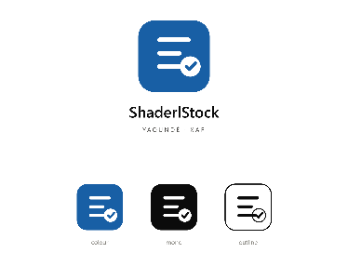
2 | ShaderlAlgorithm | It is an application, which helps individuals in the society to learn how to write algorithms and programing, despite their educational background. With the help of artificial intelligence. | 

ORGANISATION OF SHADERL
Shaderl is administratively organized as follows:

Executive Leadership
This department is responsible for:
✓ Setting the company's vision, mission, and strategic direction
✓ Making high-level decisions about investments, partnerships, and growth
✓ Representing Shaderl in key meetings with investors and government agencies
✓ Ensuring all departments align with the company's core values and objectives
✓ Overseeing the overall performance and sustainability of the organization.

Software Engineering Department
This department is responsible for:
✓ Designing, developing, and maintaining all of Shaderl's software products
✓ Implementing AI and machine learning solutions for company offerings
✓ Ensuring software security, scalability, and optimal performance
✓ Collaborating with other departments to understand technical requirements
✓ Staying updated with emerging technologies and industry best practices

Human Resource Department
This department is responsible for:
✓ Recruiting and onboarding top talent that aligns with Shaderl's values
✓ Managing employee relations, welfare, and performance evaluations
✓ Developing training programs to enhance staff skills and capabilities
✓ Maintaining company culture and ensuring a positive work environment
✓ Handling compensation, benefits, and conflict resolution

Communication Department
This department is responsible for:
✓ Managing Shaderl's public image and brand reputation
✓ Developing and executing marketing and PR strategies
✓ Handling all internal and external communications
✓ Managing social media platforms and digital content
✓ Organizing corporate events and press engagements

Department of Financial Affairs
This department is responsible for:
✓ Managing all financial operations and accounting
✓ Preparing budgets and financial forecasts
✓ Handling payroll, taxes, and financial reporting
✓ Ensuring compliance with financial regulations
✓ Managing investments and financial partnerships

Functional organisation
The functional branch of Shaderl is organized as follows:

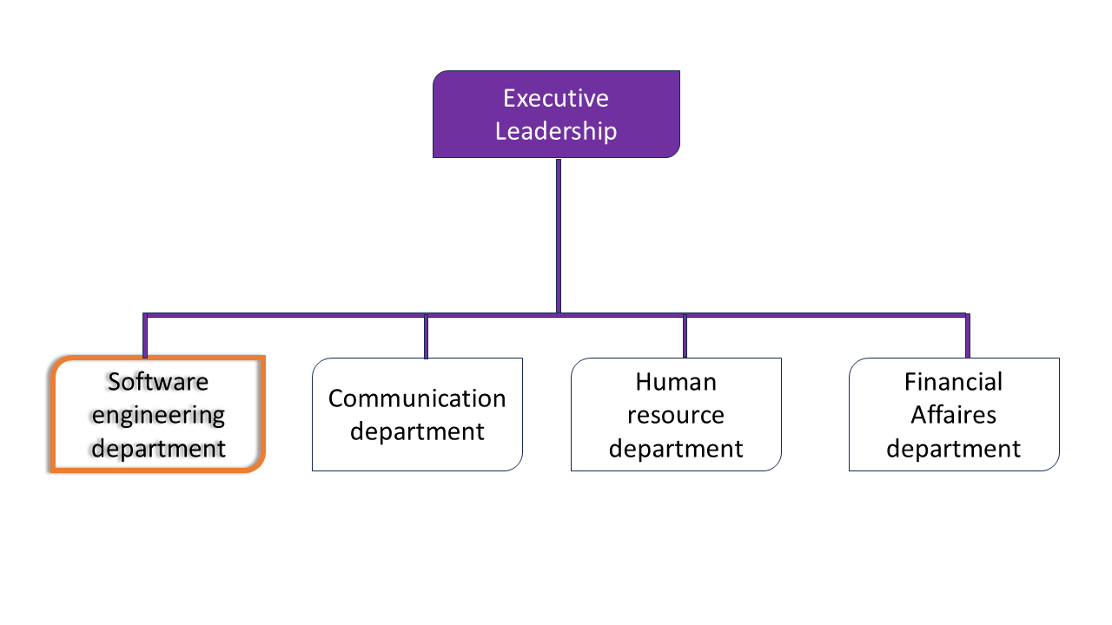
Figure 1: Organization of shaderl (shaderl)

GEOGRAPHICAL LOCATION OF SHADERL

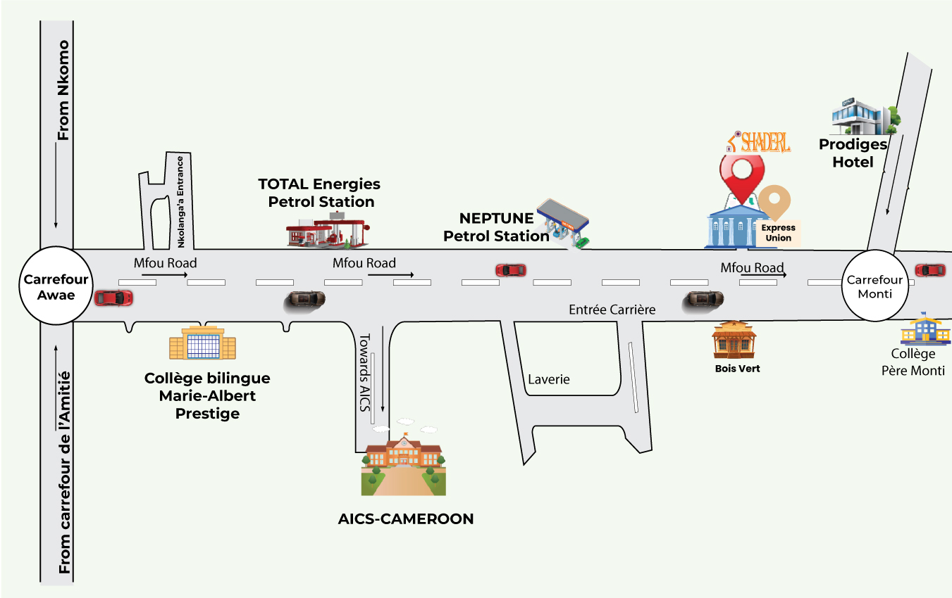
Figure 2: Geographical location of shaderl (shaderl)

V- BRIEF PRESENTATION OF THE PROJECT THEME
During our insertion phase at SHADERL, we were tasked with identifying a project theme that solves a real-world problem while introducing an innovative solution. After presenting several ideas and receiving guidance from our professional supervisor, we refined our proposal and finally selected the theme "The Conception and Realization of an AI-Powered Adaptive E-Learning Platform for Cameroon GCE Ordinary and Advanced Level Students." Many GCE students in Cameroon face challenges such as inconsistent study habits, limited access to personalized academic support, and a lack of engaging digital learning tools. Traditional revision methods provide little motivation, limited feedback, and do not effectively involve teachers and parents in monitoring students' progress. Our solution is an AI-powered Adaptive E-Learning Platform that transforms GCE revision into an interactive and engaging experience through gamification, adaptive learning, and tutoring. Students can access structured lessons, practice past GCE questions, receive AI-generated explanations, and track their academic progress. Teachers and parents can monitor student performance through dedicated dashboards, while administrators manage educational content and platform operations. In short, our platform modernizes GCE exam preparation by making learning more personalized, engaging, and collaborative for everyone involved in the educational process.

CONCLUSION
Being at the end of the insertion phase, which covered the general presentation of our company and our familiarity with the work environment. This environment gives room for hard work, perseverance and collaboration, what most students are looking for. We learned about the missions of the company, its activities. In addition, this phase was a benefit to us due to the perception of the need, importance of collaborative work and especially the most important aspect confronting the realities of the workspace.

PART TWO : TECHNICAL PHASE

Preamble
The technical phase is a document that describes the process, progress, or results of scientific research. It also includes a detailed analysis and the conclusions drawn from that research.

Content

PART I: THE EXISTING SYSTEM
PART II. THE SPECIFICATION BOOK
PART III. THE ANALYSIS PHASE
PART IV. CONCEPTION PHASE
PART V. REALIZATION PHASE
PART.VI: TEST OF FUNCTIONALITIES
PART.VII: USER GUIDE

PART I : THE EXISTING SYSTEM

Preamble
The existing system is a document that provides a view of how the current system works, how it carries out its different activities, it equally provides a deep understanding of the system associated to the various limitations and the problems that result from it and we propose the solution..

Content

INTRODUCTION
I. PRESENTATION OF THE THEME
II. DESCRIPTION OF THE EXISTING SYSTEM
III. CRITICISMS OF THE EXISTING SYSTEM
IV. PROBLEMATICS
V. PROPOSED SOLUTION
CONCLUSION

INTRODUCTION
As engineers, our role in society is to solve problems, with the goal of making life easier for everyone. To bring forth a solution, we ought to ask ourselves why the problem exists in the first place and how it is being addressed at the time. The existing system refers to the system put in place to carry out the work done in the field on which our theme is based. Understanding this system is a great step in solving the problems that we might identify. It’s of great importance that we take this system into consideration before proposing a suitable solution that will ameliorate or replace the current one.

PRESENTATION OF THE THEME
In today's digital learning environment, many Cameroon GCE Ordinary and Advanced Level students face challenges such as inconsistent study habits, limited access to personalized learning support, and a lack of engaging educational resources. Traditional revision methods often fail to motivate students to study consistently, while teachers and parents have limited means of monitoring academic progress outside the classroom. To address these challenges, we propose the development of an Adaptive Learning Platform specifically designed for Cameroon GCE students. This platform leverages gamification, adaptive learning, and artificial intelligence to make learning more interactive, personalized, and effective while strengthening collaboration between students, teachers, and parents.

DESCRIPTION OF THE EXISTING SYSTEM
The current digital learning solutions available for Cameroon GCE students, such as the Kawlo GCE App, have significantly improved access to revision materials by providing notes, past examination questions, practice exercises, and an AI chatbot for extended aid. However, despite these improvements, the platform still presents several limitations that affect the delivery of a personalized and engaging learning experience. Below is an analysis of the existing system:

a. Limited Adaptive Learning
- Static Learning Content: Most lessons are presented in a fixed format and are delivered uniformly to all learners regardless of their academic strengths, weaknesses, learning pace, or previous performance.
- Limited Learning Personalization: Although the platform includes an AI chatbot, its functionality is primarily centered on answering students' questions. It does not comprehensively analyze learner performance to adapt lessons, recommend personalized revision paths, or adjust learning materials based on individual needs.

b. User Experience Challenges
- Congested User Interface: The application interface contains a large amount of information on individual screens, making navigation less intuitive and potentially overwhelming for new users. This can reduce usability and negatively affect the overall learning experience.

c. Limited Collaborative Learning Support
- Lack of Parent and Teacher Monitoring: The existing platform does not provide dedicated dashboards that enable parents and teachers to monitor students' learning progress, identify weak areas, track revision consistency, or receive performance reports. As a result, opportunities for collaborative academic support and timely intervention are limited.

CRITICISMS OF THE EXISTING SYSTEM
The analysis of existing digital learning platforms for Cameroon GCE students, particularly the Kawlo GCE App, reveals several limitations that reduce their effectiveness in providing a personalized, engaging, and collaborative learning experience. The major criticisms include:
LIMITATIONS | CONSEQUENCES | PROPOSED SOLUTION
Static Learning Content | Students receive the same learning experience regardless of their individual learning needs, reducing learning effectiveness and knowledge retention. | Implement an AI-powered adaptive learning engine that personalizes lessons, quizzes, and revision materials according to each student's performance and learning profile.
Chatbots Limited to conversational assistance | Students receive limited personalized academic guidance, reducing the effectiveness of AI-assisted learning. | Integrate an AI tutor capable of analyzing student performance, generating personalized explanations, recommending revision topics, and adapting learning content using verified GCE marking schemes.
Limited academic supervision and monitoring | Teachers are unable to identify struggling students, assign personalized revision tasks, or provide timely academic intervention. | Develop a Teacher Dashboard that provides learning analytics, student progress monitoring, exercise assignment, and class performance reports.
Parents cannot monitor children learning progress | Parents have limited visibility into students' study habits and cannot effectively support examination preparation at home. | Develop a Parent Dashboard that enables parents to monitor learning progress, receive notifications, and access performance reports.
Limited motivation for continuous learning. | Students may lose motivation and develop inconsistent study habits, often resulting in last-minute examination preparation. | Introduce gamification features such as learning streaks, experience points (XP), achievement badges, leaderboards, and unlockable learning features to encourage regular study.
Limited Parent,Teacher and Student Collaboration | Academic support is less coordinated, reducing opportunities for early intervention and continuous learner support. | Build a collaborative learning ecosystem where students, teachers, and parents interact through progress monitoring, notifications, assignments, and performance analytics.

PROBLEMATIC
Every Cameroon GCE student learns differently. While some quickly grasp new concepts, others require additional explanations, practice, and guidance. However, many students still follow the same revision methods regardless of their individual learning needs, resulting in inconsistent study habits, reduced motivation, and inadequate examination preparation. How can we design and implement an Adaptive E-Learning Platform that adapts to each learner's strengths, weaknesses, and learning pace while promoting continuous engagement and academic success?

PROPOSED SOLUTION
To address the challenges, we propose the development of an Adaptive E-Learning Platform specifically designed for Cameroon GCE Ordinary and Advanced Level students. The platform integrates adaptive learning, gamification, and collaborative academic monitoring into a single digital solution that enhances student engagement and improves examination preparation.
Key Aspects of the Proposed Solution:
- Adaptive Learning: The platform will analyze each student's learning profile, academic performance, strengths, weaknesses, and learning pace to deliver personalized lessons, quizzes, and revision recommendations.
- Gamified Learning Experience: Learning will be enhanced through daily streaks, experience points (XP), achievement badges, leaderboards, and unlockable features that motivate students to develop consistent study habits.
- AI-Powered Tutoring: An AI tutor, built using a Hugging Face model, will provide personalized explanations, answer students' academic questions and recommend revision topics.
- Collaborative Progress Monitoring: Dedicated dashboards will enable teachers and parents to monitor students' learning progress, identify weak areas, assign revision activities, receive performance reports, and support students throughout their preparation for the GCE examinations.

CONCLUSION
Having reached the end of this chapter, we examined the existing digital learning systems available for Cameroon GCE students, identified their and proposed the development of an Adaptive E-Learning Platform for Cameroon GCE Ordinary and Advanced Level Students as an innovative solution.

PART II : SPECIFICATION BOOK

Preamble
The Specification book is a document which is been established by the customer needing a particular product and the producer (engineer) who is to create the product, which is to be respected to its fullness during the realization of the product. From this, we obtain the major importance of the specification book.

Content

INTRODUCTION
- CONTEXT AND JUSTIFICATION
- OBJECTIVES OF THE PROJECT
- EXPRESSION OF NEEDS
- PROJECT PLANNING
- PROJECT COST ESTIMATION
- LIST OF PARTICIPANTS
- DELIVERABLES
CONCLUSION

INTRODUCTION
The specification book of our report helps us provide details about our theme to improve our understanding of it and increase the likelihood of it succeeding. To delimitate the scope of our project, we will specify the context of our theme. From the context, we will list the problems we have decided to address throughout the project. After presenting our solution, we will talk about the objective we have set for the project. Also, we will explore the needs to which our system will respond both at the functional and non-functional level. We will then look at the estimated financial requirements for our project and establish a plan we will follow to complete our project on time. From here, we will discuss what is expected of us by the end of the project under the project deliverables.

I. CONTEXT AND JUSTIFICATION

1. Context
Over the past decade, digital technologies have significantly transformed the education sector worldwide by making learning more accessible, interactive, and personalized. In Cameroon, however, many General Certificate of Education (GCE) students still face challenges such as inconsistent study habits, limited access to personalized academic support, and a lack of engaging digital learning platforms specifically designed for the Cameroon GCE curriculum. Although applications such as the Kawlo GCE App have improved access to revision materials and practice questions, several limitations remain, including:
- Predominantly static learning content that does not adapt to each student's strengths, weaknesses, and learning pace.
- Limited AI-driven personalization, where existing AI features are mainly conversational rather than fully integrated into adaptive learning.
- Limited collaboration between students, teachers, and parents, making it difficult to monitor learning progress and provide timely academic support.
The rapid growth of smartphone usage, internet connectivity, and artificial intelligence technologies presents an excellent opportunity to modernize GCE examination preparation through an Adaptive E-Learning Platform that delivers personalized, engaging learning experiences.

2. Justification
As Cameroon continues to embrace digital transformation in education, there is an increasing need for innovative learning platforms capable of addressing the diverse learning needs of GCE students. The proposed Adaptive E-Learning Platform is justified for the following reasons:
1. Need for Personalized Learning
- Every student learns at a different pace and possesses unique strengths and weaknesses.
- Traditional and existing digital learning platforms provide largely uniform learning experiences, making personalized academic support difficult.
2. Improving Student Engagement
- Many students struggle to maintain consistent study habits due to limited motivation.
- Incorporating gamification techniques such as learning streaks, achievement badges, experience points (XP), and unlockable features can encourage continuous learning and improve examination preparedness.
3. Advances in Artificial Intelligence
- Modern AI technologies make it possible to analyze student performance and generate personalized lessons, explanations, quizzes, and revision recommendations.
- Integrating AI into GCE preparation can provide students with academic assistance that complements traditional classroom learning.
4. Strengthening Collaborative Learning
- Teachers and parents play a crucial role in students' academic success but currently have limited visibility into students' learning activities on most digital platforms.
- Dedicated monitoring dashboards will enable teachers and parents to track progress, identify learning difficulties, assign revision activities, and provide timely academic support.
5. Technological Readiness
- The increasing adoption of smartphones, affordable internet services, and cloud-based technologies provides a strong foundation for deploying an accessible and scalable Adaptive E-Learning Platform across Cameroon.

II. OBJECTIVES OF THE PROJECT

1. General Objective
The primary goal of this project is to design and implement an Adaptive E-Learning Platform that enhances the preparation of Cameroon GCE Ordinary and Advanced Level students through personalized learning, artificial intelligence, gamification, and collaborative academic monitoring involving students, teachers and parents.

2. Specific Objectives
To achieve this, the system will:
❖ Provide Adaptive and Personalized Learning
- Deliver personalized lessons and quizzes based on each student's strengths, weaknesses, learning pace, and academic performance.
- Recommend revision topics and learning paths using artificial intelligence.
❖ Improve Student Engagement
- Encourage consistent learning through gamification features such as daily learning streaks, achievement badges, experience points (XP), leaderboards, and unlockable learning content.
- Provide structured lessons, practice quizzes and past Cameroon GCE examination questions.
❖ Enhance AI-Assisted Learning
- Integrate an AI tutor capable of answering students' academic questions.
- Generate personalized explanations and revision recommendations based on verified Cameroon GCE marking schemes.
❖ Strengthen Teacher and Parent Involvement
- Enable teachers to monitor student performance,
- Allow parents to monitor their children's learning activities, receive progress notifications, and access academic performance reports.
❖ Facilitate Learning Management
- Maintain secure student profiles, learning history, achievements, progress reports, and subject resources within a centralized database.
- Provide administrators with tools to manage users, subjects, question banks, learning resources, and overall platform operations.

III. EXPRESSION OF NEEDS

1. FUNCTIONAL NEEDS
Functional needs describe the services and functionalities that must be provided to the users. They are listed as follows:
i. User Authentication and Access Control
The system must allow users (students, teachers, parents, and administrators) to securely register and log in using their credentials. Different user roles must have access only to the features and information relevant to their responsibilities. The system must also support role-based authorization to ensure data security and privacy.
ii. Adaptive Learning Management
The platform must provide personalized learning experiences by analyzing each student's learning history, strengths, weaknesses, learning pace, and academic performance. Based on this analysis, the system should recommend appropriate lessons, quizzes, and revision materials tailored to the individual learner.
iii. AI-Powered Tutoring
The platform must integrate an Artificial Intelligence tutor capable of answering students' academic questions, generating personalized explanations based on verified Cameroon GCE marking schemes, recommending revision topics, and providing guidance throughout the student's learning journey.
iv. Gamified Learning System
The system must motivate students through gamification features such as daily learning streaks, experience points (XP), achievement badges, leaderboards, and unlockable premium features. Student progress should be updated automatically as learning activities are completed.
v. Learning and Assessment Management
The platform must enable students to access structured lessons, practice quizzes, mock examinations, and past Cameroon GCE examination questions. It should automatically evaluate objective assessments and provide immediate feedback after each learning activity.
vi. Teacher Dashboard
Teachers must have access to a dedicated dashboard that enables them to:
- Monitor students' academic performance and learning progress.
- Assign revision exercises and practice activities.
vii. Parent Dashboard
Parents must have access to a dedicated dashboard that allows them to:
- Monitor their children's learning progress.
- View performance reports and learning statistics.
- Receive notifications on completed lessons, examination results, and learning milestones.
- Track students' learning consistency through streaks and activity history.
viii Administrative Dashboard
Administrators must have access to a management dashboard that enables them to:
- Manage users (students, teachers, parents, and administrators).
- Approve teacher verification requests.
- Manage subjects, lessons, learning resources, and question banks.
- Monitor overall platform usage and learning analytics.

2. NON-FUNCTIONAL NEEDS
Non-functional requirements are a set of criteria that define the overall qualities, characteristics, and constraints of a software system, rather than its specific behaviors or functions. These requirements describe how the system should operate, rather than what it should do.

- Performance: The platform should provide fast response times when students access lessons, complete quizzes, interact with the AI tutor, or view their progress.
- Reliability and Availability: The application should maintain high availability with minimal downtime, allowing users to access the platform whenever needed. Learning progress, assessment results, and user information should be reliably stored and consistently available.
- Usability: The platform should provide a clean, intuitive, and user-friendly interface that enables users of different technical backgrounds to navigate the application easily.
- Maintainability: The application should be developed using a modular and well-documented architecture to facilitate future maintenance, testing, and enhancement..
- Security: The platform should implement robust security mechanisms to protect users' personal information. Authentication and role-based authorization should ensure that students, teachers, parents, and administrators can only access resources relevant to their roles. Some of the security principles include confidentiality, Integrity and Authentication.

IV. PROJECT PLANNING
For the successful realization of our project, we would need to progress through several sequential steps in a period of 3 months. To help us stay on track and on time, we have represented the schedule phases of our project in a Gantt chart.

1. Chronogram of activities:
Table 2 chronogram of activities
Phase | Objective | Duration | Output
Insertion | This stage involves gathering all the relevant information and requirements for the project. | 2 weeks | Insertion report
Existing system | Bring out the structure of a system that exists | 5days | Existing system
Specification Book | The specification book is a document that outlines the detailed specifications and requirements of the school fee tracking and payment reminder system. It includes the functional and non-functional requirements. | 5day | Specification Book
Analysis | The analysis stage involves analyzing the gathered requirements and conducting a feasibility study. This helps determine the technical and economic viability of the project. | 2 weeks | Analysis Book
Conception | In the conception stage, the project's conceptual design is developed. This includes defining the system architecture, selecting the appropriate technologies, and creating the initial design project plan | 2 weeks | Conception book
Realization | Build the school fee tracking and payment reminder system by designing and assembling hardware components, developing software, and ensuring proper functionality | 3 weeks | Realization book
Test of functionalities | Ensures that all system functionalities work properly as required | 5days | Test of functionalities
User guide | Provide comprehensive documentation and instructions on system operation, user interface navigation, troubleshooting and maintenance procedures. | 5days | User Guide
Finalizing the report |  | 3days | Final report

2. Gantt chart
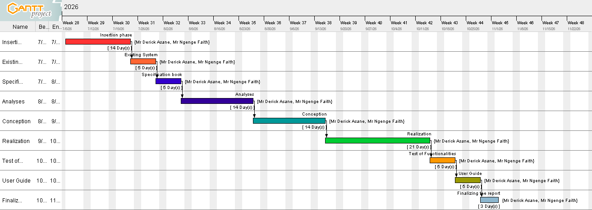
Figure 3: Gantt project planning

V. ESTIMATED COST OF PROJECT

1. SOFTWARE’S RESOURCES
Table 3 Software resources
Resource | Resource Designation | Usage | Quantity | Unit Cost (FCFA)
Text editing & Presentation | Microsoft Office 2021 Professional Plus | Writing of the report (Word) and designing a presentation (PowerPoint) | 1 | 79,063
Operating System | Microsoft Windows 10 | Computer operating system | 1 | 123,625
Database management | Mongodb | To communicate with the database | 1 | Free Download
Web browser | Google Chrome | View web pages | 1 | Freeware
Code Editor | Visual Studio Code | For writing the code of the application | 1 | Freeware
Project planning | Gantt Project | For building a Gantt chart | 1 | Freemium
Open router | Mistral | AI integration | 1 | Freemium
Illustrating tool | Echogram | For building a geographical location of the enterprise | 1 | Freemium
UML Analysis | Visual Paradigm | For drawing UML diagrams | 1 | Freemium
Total |  |  |  | 202,688
(Mercurial, 2026)

2. HARDWARE RESOURCES

Table 4 hardware resources
Resource | Usage | Quantity | Unit Cost(FCFA)
LENOVO think pad  Core i5 | Used for the creation of the report, the PowerPoint and coding | 1 | 402,500
STARLINK | For network connectivity | 1 | 25000
USB KEY 64GB | For sharing of software and some document backup | 1 | 14000
Smart phone | For doing research, and communicating | 1 | 150,000
Total 1 |  |  | 591,500
(Mercurial, 2026)

3. HUMAN RESOURCES
Table 5 Human resources
ROLE | NUMBER OF DAYS | QUANTITY | COST PER DAY (FCFA) | TOTAL PRICE (FCFA)
Project Manager | 90 | 1 | 30,000 | 2,700,000
Analyst | 21 | 1 | 25,000 | 700,000
UI/UX Designer | 7 | 1 | 20,000 | 140,000
Programmer | 30 | 1 | 15,000 | 400,000
Tester | 14 | 02 | 10,000 | 110,000
Total |  |  |  | 4,050,000

4. TOTAL PROJECT ESTIMATION
Table 6 Total Estimated Cost
Total1 | Total2 | Total3 | Overall total
202,688 | 591,500 | 4,050,000 | 4,844,188
FOUR MILLION FIVE HUNDRED AND FIFTY FOUR THOUSAND FCFA

CONSTRAINTS OF THE PROJECT
- Technical constraint: For the development of our system, we have sufficiently robust tools to guarantee a minimum of security, extensibility, and excellent scalability. Moreover, the programming phase will have to follow all the technical standards for a better performance in a reduced execution time; this is why the choice of the development technologies is crucial.
- Time Constraint: The required deadline is 03 months after the validation of this document, starting from the beginning date, 06th July 2026.
- Cost constraint: The realization of our project will require expenditures in human resources, materials, and very limited software.

LIST OF PARTICIPANTS AND DELIVERABLES

1. LIST OF PARTICIPANTS
Table 7 List of Participants
NAME | FUNCTION | ROLE
MR NGENGE FAITH | Consultant at SHADERL | Professional supervisor at SHADERL
Mr. ASSANE DERICK | Lecturer at African Institute of Computer Sciences | Academic Supervisor
NJINI FAVOUR BEMSIMBOM | Project head, analyst, conception and coding of the project, testing | Student at AICs CAMEROON

2. DELIVERABLES
In project management, any component materializing the result of a realization service is called a deliverable. In the case of our project, the deliverables are
- The application
- The user guides.
- The PowerPoint and the report.

CONCLUSION
Reaching the end of this part. The list of objectives to be achieved has been enumerated and made clear. The specification book permitted us to present the different actors associated with the project as well as the requirements and the provisional planning needed for the achievement of our project. We will move directly to the next part, which is the analysis phase. In the analysis phase, we will model our system with a modelling language and a unified process and do a comparative study of UML and MERISE.

PART III : THE ANALYSES PHASE

Preamble
The main objective of the analysis phase is to capture the user’s need, the delimitation of the field of study and to have a clear understanding of the system in study. To achieve this, we will use UML (Unified Modelling Language) with the 2TUP (2 Track Unified Process) as method applied to UML to analyze the system. We will start by doing a comparison between UML and MERISE, of various unified processes and lastly, we will present the modelling of the solution we propose (Our software).

Content

INTRODUCTION
I. METHODOLOGY
1. COMPARATIVE STUDY OF UML AND MERISE.
2. COMPARATIVE STUDY OF UNIFIED PROCESSES.
II. CHOICE OF THE ANALYSIS METHOD
1. MODELLING OF THE PROPOSED SOLUTION
CONCLUSION

INTRODUCTION
System development can be thought of as having two major components: System analysis and system design, which both help in understanding the details of the existing system or the system to be designed. The analysis and design of information systems has most of the time vocation to allow the creation of databases, which must represent as closely as possible the reality of the field studied, thus requiring the use of a design method. This is why our choice will be directed towards the UML method as it offers much to developers seeking a user-centered approach and/or a wide scope in design. This part of the report consists of the comparative study of UML and MERISE, unified processes, and finally the various diagrams that meet the functional need requirements.

I. METHODOLOGY

1. Comparative study of UML and MERISE

MERISE
MERISE stands for “Méthode d’Étude et de Réalisation Informatique pour des Systèmes d’Entreprise”. MERISE is a method for designing, developing, and carrying out IT projects. The goal of this method is to achieve the design of an information system. The MERISE method is based on the separation of data and processing to be carried out in several conceptual and physical models. The essentials of the approach lie in its three cycles: the decision cycle, the life cycle, and the abstraction cycle, which cover data and process elements equally. The separation of data and processing ensures longevity in the model. Indeed, the arrangement of data does not have to be often overhauled, while treatments are more frequently.

UML
UML (Unified Modeling Language) is a standard notation for the modeling of real-world objects as a first step in developing an object-oriented design methodology. Its notation is derived from and unifies the notations of three object-oriented design and analysis methodologies: Grady Booch's methodology for describing a set of objects and their relationships, James Rumbaugh's Object-Modeling Technique (OMT), and Ivar Jacobson's approach, which includes a use case methodology. Other ideas also contributed to UML, which was the result of a work effort by Booch, Rumbaugh, Jacobson, and others to combine their ideas, working under the sponsorship of Rational Software. UML captures information about the static and dynamic views of a system. UML 2.5 comprises 14 diagrams that represent the different views of a system. The 14 diagrams can be subdivided into two: Static or structural diagrams and Dynamic diagrams. These diagrams include;

i. Structural diagrams
- The class diagram
- The object diagram
- The package diagram
- The composite structure diagram
- The component diagram
- The deployment diagram
- The profile diagram

ii. Behavioral Diagram
- The use case diagram
- The activity diagram
- The sequence diagram
- The state machine diagram
- The communication diagram
- The timing diagram
- The interaction overview diagram
(Group, 2017)

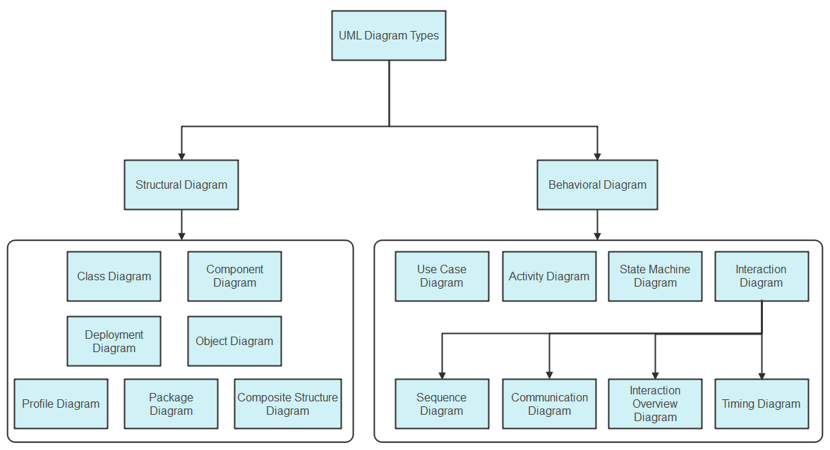
Figure 4: UML Diagram overview

It is important to note that UML is a modeling language and not a method or procedure. Hence, to give it an approach, we need to associate UML with a unified process (UP) to give our conception a methodology to follow. A unified process is a generic method for developing software. This implies that it is necessary to adapt the UP to the context of the project team domain and or the organization. We will use the Two Tracks Unified Process (2TUP) throughout our project to implement our solution.

Table 8 Differences between Merise and UML
MERISE | UML
It represents 'Méthode d'Étude et de Réalisation Informatique pour les Systèmes D’Entreprises' and 'Unified Modeling Language'. | Unified Modeling Language
MERISE is a systemic method of analysis and design of information systems. That is, it uses a systems approach. | UML is, however, not a method but rather an object modeling language to which it is necessary to associate an approach to make it a method. This is the case with the 2TUP method, RUP, and XP.
MERISE proposes to consider the real system from two points of view:  - A static view (data)  - A dynamic view (treatments). That is, with the MERISE method, we have a separate study of the data and the treatments. | UML offers a different approach from that of MERISE in that it combines data and processing. With UML, centralizing the data of a type and the associated processing makes it possible to limit the maintenance points in the code and facilitates access to information in the event of software development. In addition, UML describes the dynamics of the information system as a set of operations attached to the objects of the system.
Rational | Object

2. Comparative study of the Unified Process

a. Unified Process
A Unified Process is a process of development of software constructed on UML; it is iterative, incremental, centered on architecture, driven by use cases and requirements.
- Iteration is a distinct sequence of activities with a basic plan and evaluation criterion that produces an internal or external output. Either the content of an iteration is improved, or the evolution of the system is evaluated by users.
- An increment is the difference between two released products at the end of two iterations. Each iteration in the group is capable of integrating the technical environment in order to develop a final product and give users the possibility of having tangible results.
- Centered on architecture, the different models derived during the establishment of the system must be reliable and coherent.
- Driven by use cases and requirements enables the clear definition of a user’s needs and priorities, respectively, thereby minimizing the risk of project failure.

b. The Two Track Unified Process (2 TUP)
2TUP is a unified process that is built on UML and has as its objective to bring a solution to constraints of functional and technical changes imposed on information systems by strengthening controls on development capacities. It proposes a Y-shaped development life cycle that separates the functional aspect from the technical aspects, and the merging of these two forms the implementation aspect. 2TUP distinguishes, therefore, two branches: the functional and technical branches. The combination of the results of these two branches forms the third: the realization branch, where we realize our system. The diagram below illustrates the branches of 2TUP.
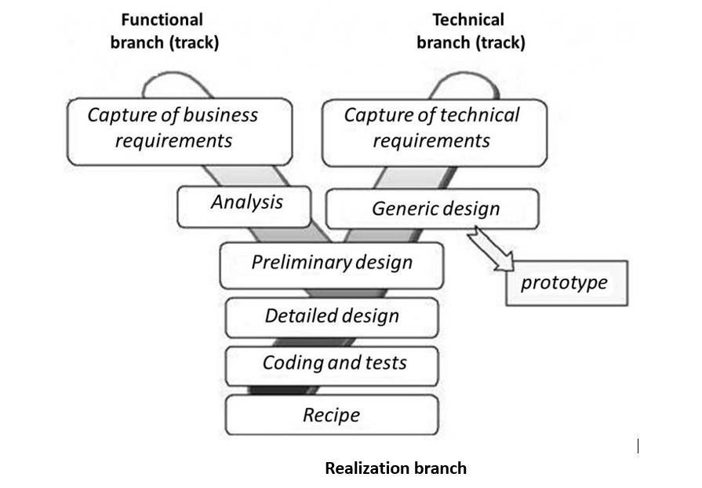
Figure 5 Two Track -unified process
2TUP is an approach that makes it possible to visually represent the different stages and components of a software project using UML diagrams. It proposes a development cycle in the Y shape, which separates the functional aspects from the technical aspects. It begins with a preliminary study, which consists of identifying the actors that will interact with the software to be built and the messages that the actors and the system exchange.
2TUP is based on three phases:

The Functional Branch(left branch)
It captures the functional needs of a system. This ensures the production of software that meets the needs/requirements of the user. The analysis here consists of studying precisely the functional specification in order to obtain an idea of what the system is going to realize, and its result does not depend on any technology.

The Technical Branch
The technical branch lists the technical needs and proposes a generic design validated by a prototype. The preliminary techniques revealed in the preliminary study, showing the operational needs and the strategic choices of development, lead to the development of the construction process. To do this, some stages are necessary:
- The inventory of technical specifications related to the hardware.
- The inventory of the software specifications.

Implementation branch(middle branch)
In this branch, we study the preliminary conception, detailed conception, and documentation of the system. The realization branch supports the following: Preliminary conception: This is the most sensitive step of 2TUP as it is the confluence of the functional and technical branch. It is completed when the deployment model, the operating model, the logical model, interfaces, and the software configuration model are defined. We have the following diagrams:
- Component Diagram;
- Deployment Diagram;
- Package Diagram;
- Composite Structure Diagram;
Detailed conception: This is the detailed design of each feature of the system. We have the following diagrams:
- Class;
- Sequence;
- Object;
- Timing diagram;
Coding and testing: This is the phase where we program the designed features and test the coded features.
The recipe: Also known as the deliverables, is the validation phase of the functions of the developed system.

II. MODELLING OF THE SYSTEM

1) Use Case diagram

a. Definition
A use case diagram shows the functionalities of a system, their inter-dependencies, and how they relate to the actors of the system. A use case is a specification of behavior.
The main objectives of the use case diagram are:
- Provide a high-level view of the system;
- Identify the functions of the system.
Use case diagrams are completed with a textual description of each use case that is intended to define the use case in greater detail.

b. Formalism
Figure 6: Use case formalism
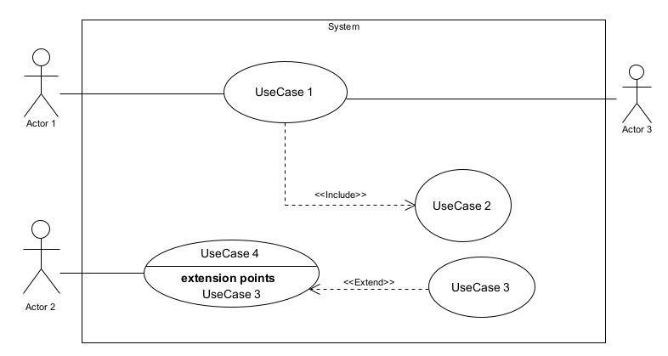
c. Elements of use case diagram
Table 9:elements of a use case diagram
Elements Notation Description
Actors | 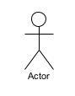 | Represents an entity that directly interacts with the system. The actor is what performs the different possible actions of the system.
Use case | Use Case  1 | A use case represents a  functionality of the system. It is an action that can be performed by an actor.
Association | 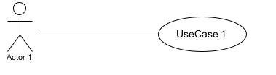 | It indicates that an actor takes part in a use Case.
Include | 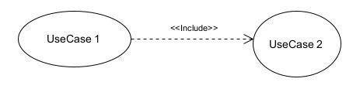 | An inclusion denotes that an included action must be performed before the including action can be performed.
Extend | 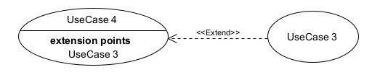 | An extension denotes that an extending action may be performed while an extended action is being performed.
Generalization | 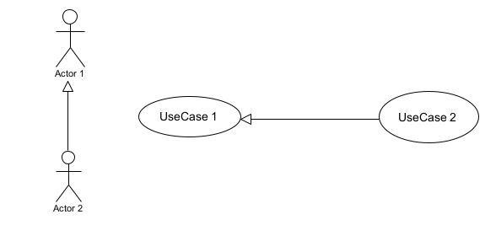 | This shows that an actor or a use case is a kind of another abstract or concrete actor that can be defined and later specialized using a generalization relationship.
System | 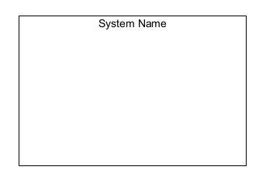 | It is a container of use cases that interact with external actors.

d. The Actors of Our System

Primary actors
Table 10: primary actors of our system
ACTORS | ROLE
Student | Registers on the platform, selects GCE level and subjects, studies lessons, takes quizzes and mock examinations, interacts with the AI tutor, tracks learning progress, and invites parents to monitor performance.
Teacher | Requests a teacher account, manages classes, assigns exercises, monitors student progress, analyzes learning performance, and provides academic guidance.
Parent | Requests access to monitor a student's account, views the student's learning progress, receives learning activity notifications, and monitors academic performance.
Administrator | Manages user accounts, approves teacher accounts, manages subjects, lessons, question banks, learning resources, and monitors overall platform analytics and operations.

Secondary actors
Table 11 Secondary actors of our system
ACTORS | ROLE
AI Tutor (Mistral AI API) | Generates personalized explanations, answers students' academic questions, provides adaptive feedback, identifies learning weaknesses, and recommends suitable study materials.
Payment Gateway (Optional - Premium Version) | Processes subscription payments for premium features such as unlimited AI tutoring, advanced analytics, exclusive revision materials, and additional mock examinations.

e. General Use Case
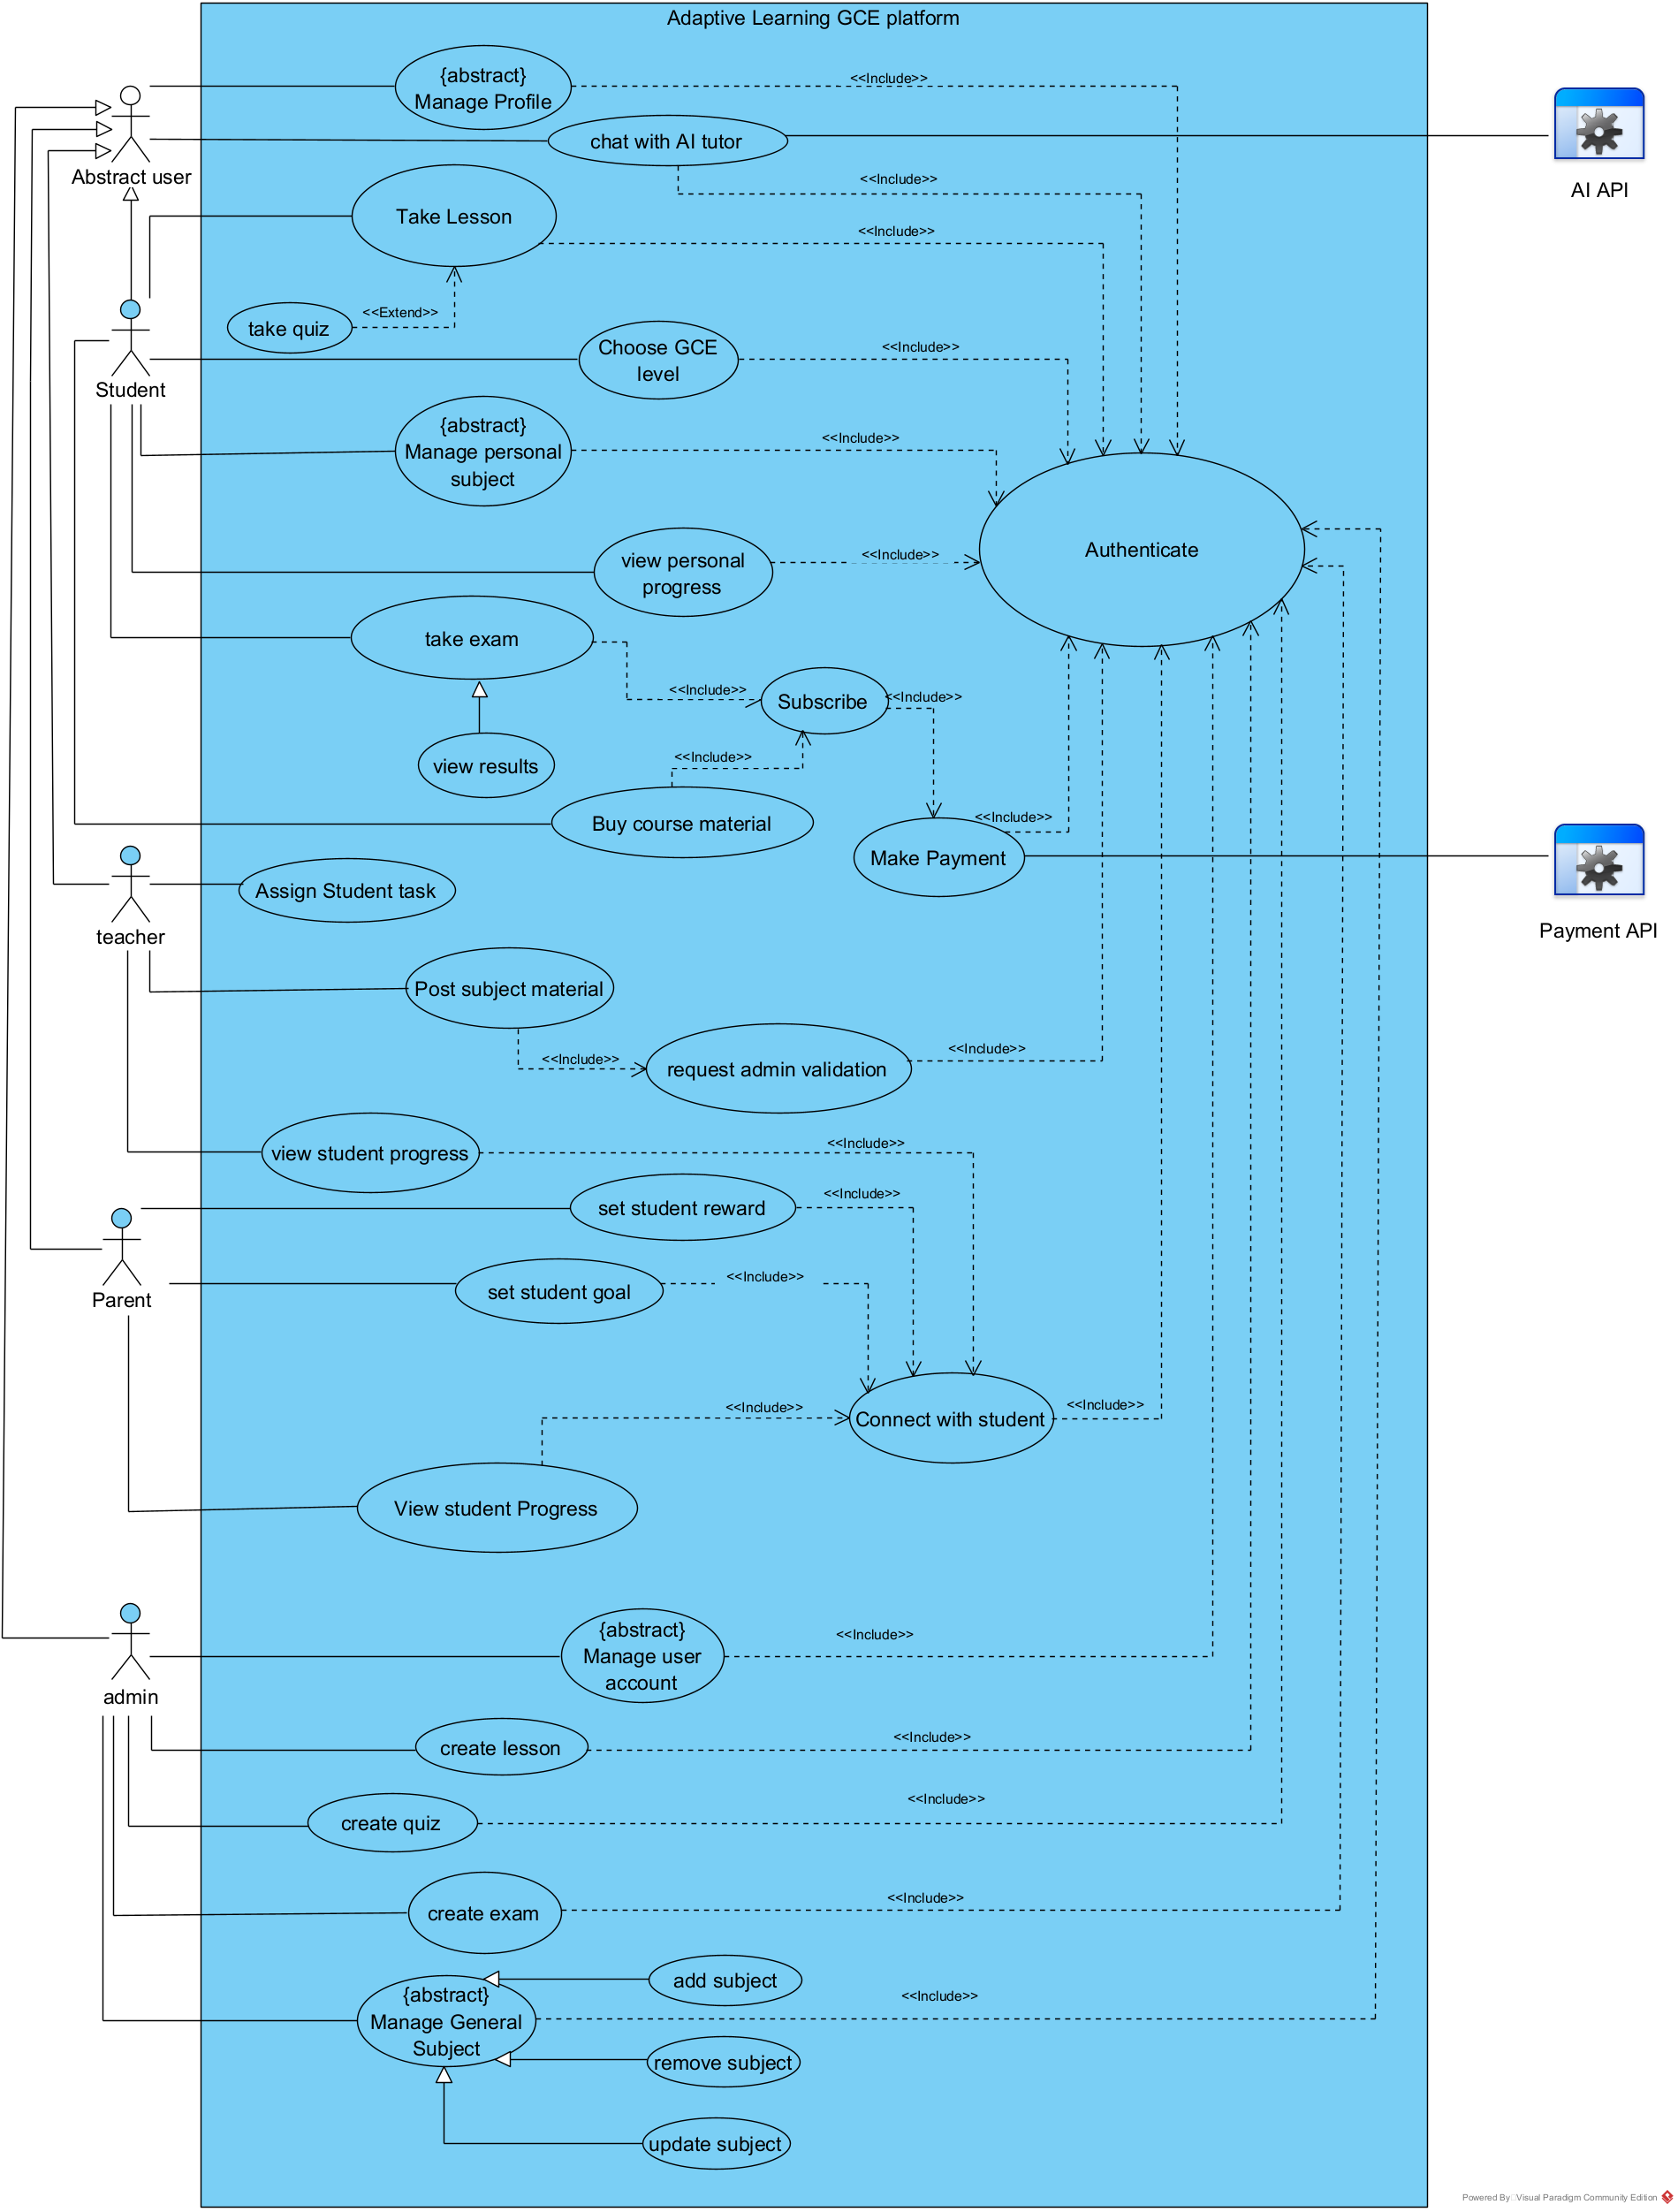
Figure 7: General Use Case of the ALP

f. Specific use case for managing user account.
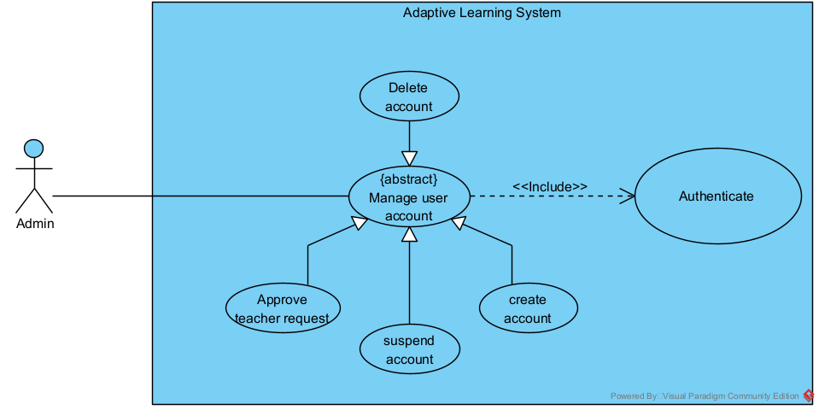
Figure 8: Manage user account

g. Specific use case for managing personal subject
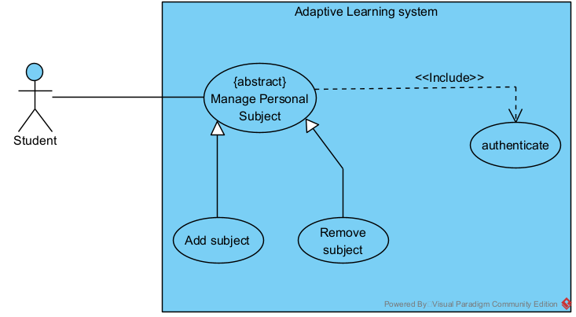
Figure 9: Manage personal subject

h. Textual description for Authentication
Title
Summary | The user needs to authenticate
Actors | Student, Parent, Teacher, Admin
Date | August 11, 2026
Stakeholder | Mr. NJINI FAVOUR BEMSIMBOM
Version | 1.0
Precondition (s) | The application is launched. The user must have an account on the platform.
Triggers | The user clicks on the login button.
Nominal Scenario | - The system displays the login form.  - The actor fills and submits the form.  - The system verifies the form (fields) conformity  - The system sends the data to the DBMS.  - The DBMS executes the authentication query  - The DBMS sends the results to the system  - The system processes the results sent by the DBMS  - The user receives a successful message displayed by the system.
Alternative Scenarios | At step 4 of the nominal scenario, the user enters mismatched or missing information.  The system displays an error message and then returns to step 2 of the nominal scenario.

i. Textual description for making payment

Field | Content
Title | Make Payment / Subscription
Summary | The user selects a subscription plan and makes a payment to access premium features.
Actors | Student
Date | August 14, 2026
Stakeholder | Mr. NJINI FAVOUR BEMSIMBOM
Version | 1.0
Precondition(s) | The application is launched. The student is authenticated on the platform.
Triggers | The student clicks on the subscription plans button from their profile page.
Nominal Scenario | 1. The student navigates to the profile page.  2. The system displays the profile page.  3. The student clicks on subscription plans.  4. The system displays the available subscription plans.  5. The student selects a plan.  6. The system displays the payment form.  7. The student fills out and submits the payment form.  8. The system validates the form fields.  9. The system sends a payment transaction request to the Payment API.  10. The Payment API executes the payment transaction and sends the transaction result back to the system.  11. The system checks the transaction result (ok).  12. The system sends a transaction save query to the DBMS.  13. The DBMS executes the query and sends the query results back to the system.  14. The system checks the database result (ok).  15. The system displays a success message to the student.
Alternative Scenario(s) | At step 8 of the nominal scenario, the user enters mismatched or missing information.  • The system displays an error message and redirects the student back to Step 6 (display payment form).  At step 11 of the nominal scenario, there is an API transaction error  • The Payment API returns a failed transaction status  • The system displays an error message and redirects the student back to Step 6 (display payment form).  At step 14 of the nominal scenario, the DBMS fails to save transaction  • The database fails to record or save the transaction (Check result = not ok).  • The system displays an error message and redirects the student back to Step 6 (display payment form).

2) Communication Diagram

a. Definition:
It is a diagram that is used to show the relationship between the actors of a system, both the sequence and the communication diagrams represent the same information but differently. Instead of showing the flow of messages. It depicts the architecture of the objects residing in the system, as it is based on object-oriented programming.

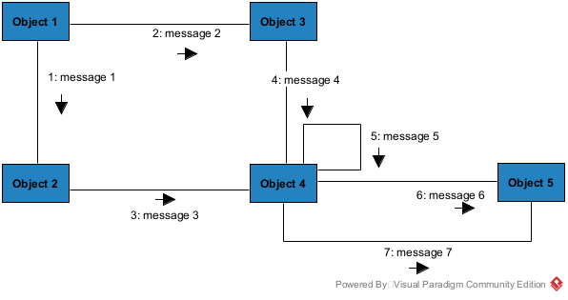
b. Formalism
Figure 10: formalism for communication diagram

c. Elements of a Communication Diagram
Table 12: elements of the communication diagram
Element | Representation | Description
Object | 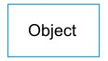 | An actor represents an individual participant in the interaction conversation.
link |  | It initiates an association it connects two objects together for them to communicate.
Actor | 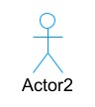 | A role play by an entity that interacts with the subjects.
message | 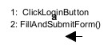 | Defines a particular communication between lifelines in an interaction.

d. Authentication Communication Diagram
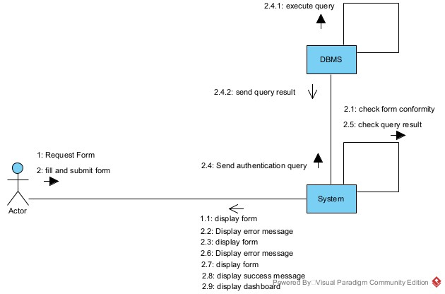
Figure 11: Authentication Communication Diagram

e. Level Selection Communication Diagram
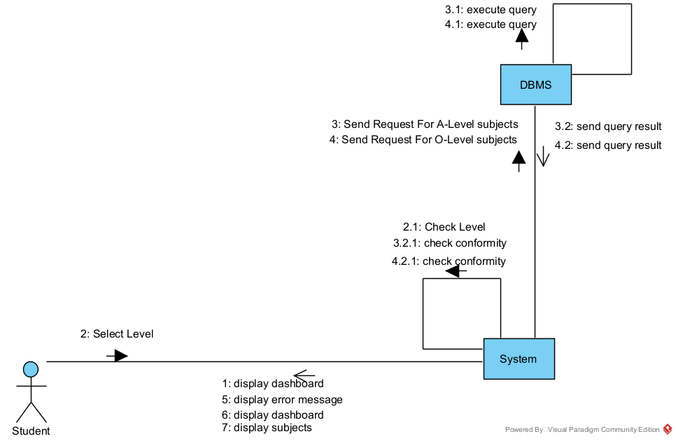
Figure 12: Select level communication diagram

f. Payment Communication Diagram
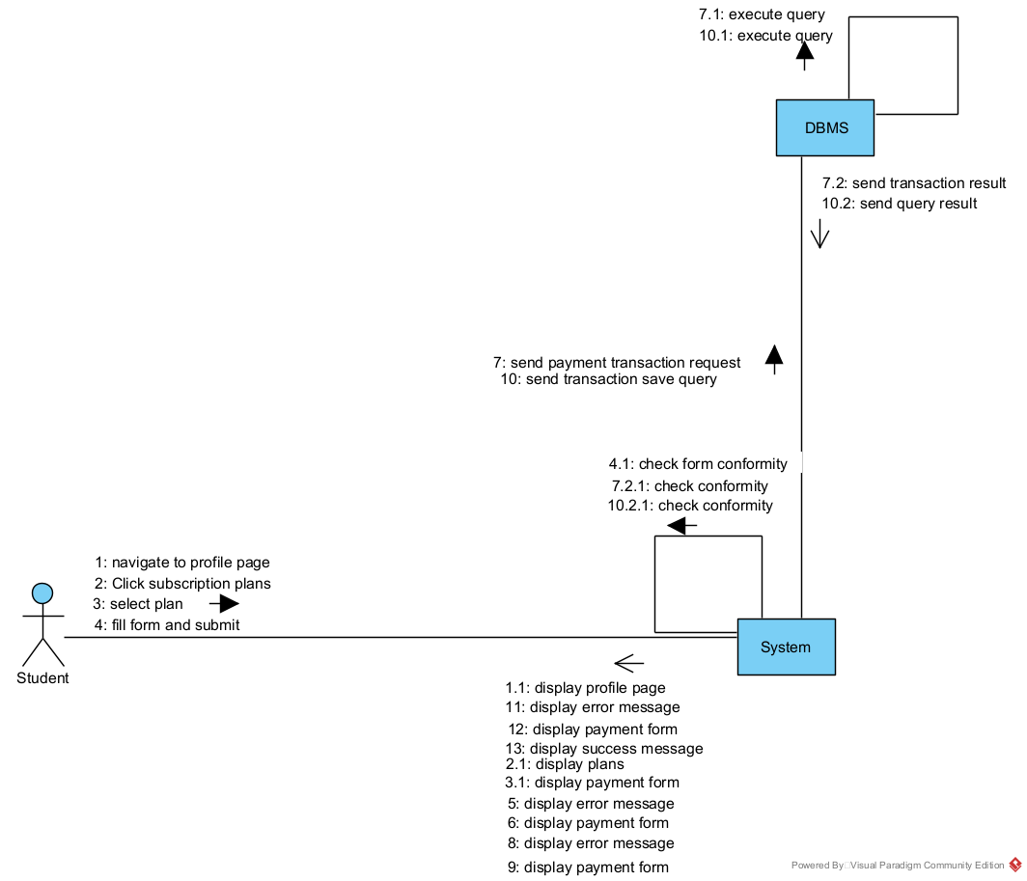
Figure 13: Make Payment Communication Diagram

3) Sequence diagram

a. Definition
A sequence diagram is an interaction diagram that represents the flow of messages between elements in a system, it is termed an event diagram. It portrays the communication between any two lifelines as a time-ordered sequence of events.

b. Formalism
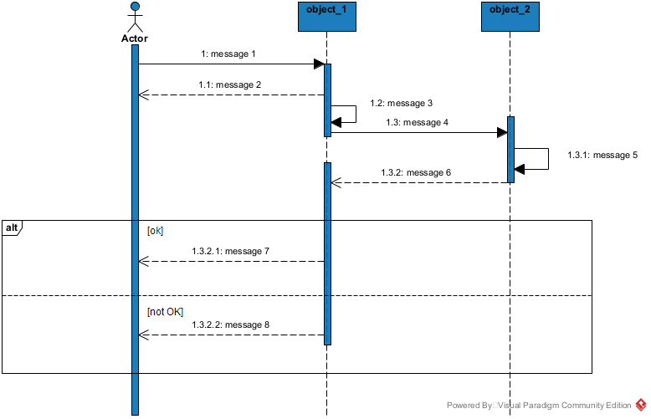
Figure 14: formalism for sequence diagram

c. Elements of a Sequence Diagram
Table 13: elements of a sequence diagram
Element | Representation | Description
Lifeline | 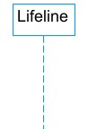 | An individual participant in a sequence diagram, it is position at the top of the diagram.
Combined fragment | 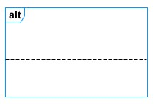 | It represents a choice of behavior in which at most one operand will be chosen.
Messages | 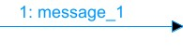  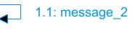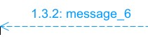 | These are arrows which shows the direction of message flow. We have the synchronous, the asynchronous and the self -messages.
Activation | 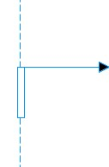 | It describes the time period in which an operation is performed by an element.

d. Authenticate sequence Diagram
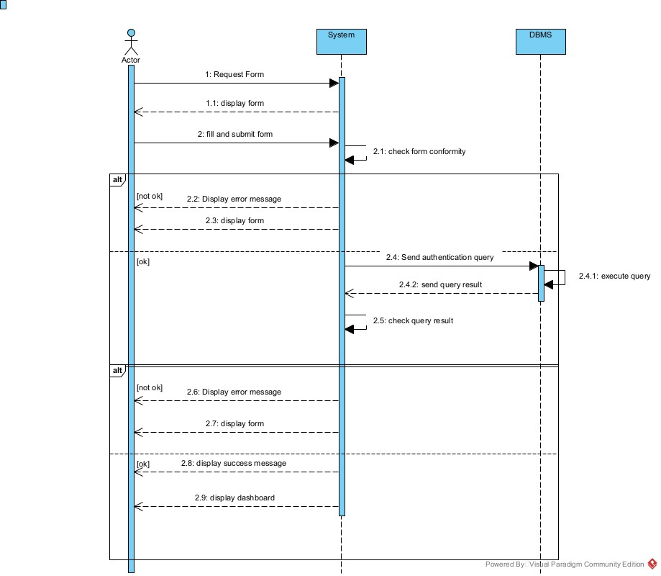
Figure 15: Authentication Sequence Diagram

e. Level Selection Sequence Diagram
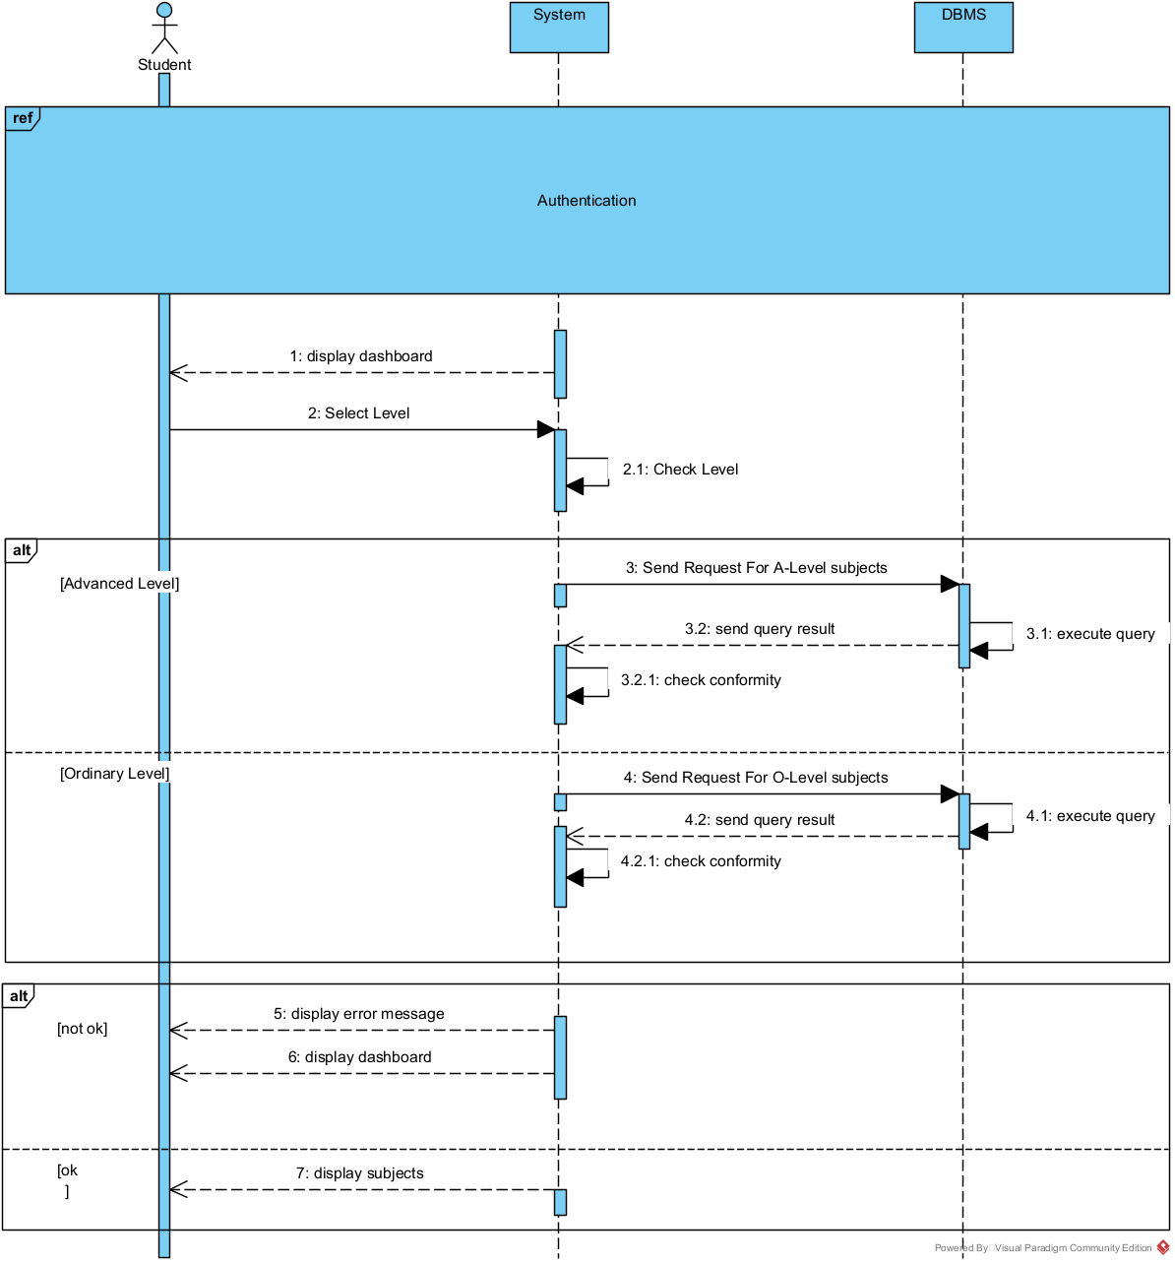
Figure 16: Select Level sequence diagram

f. Payment Sequence Diagram
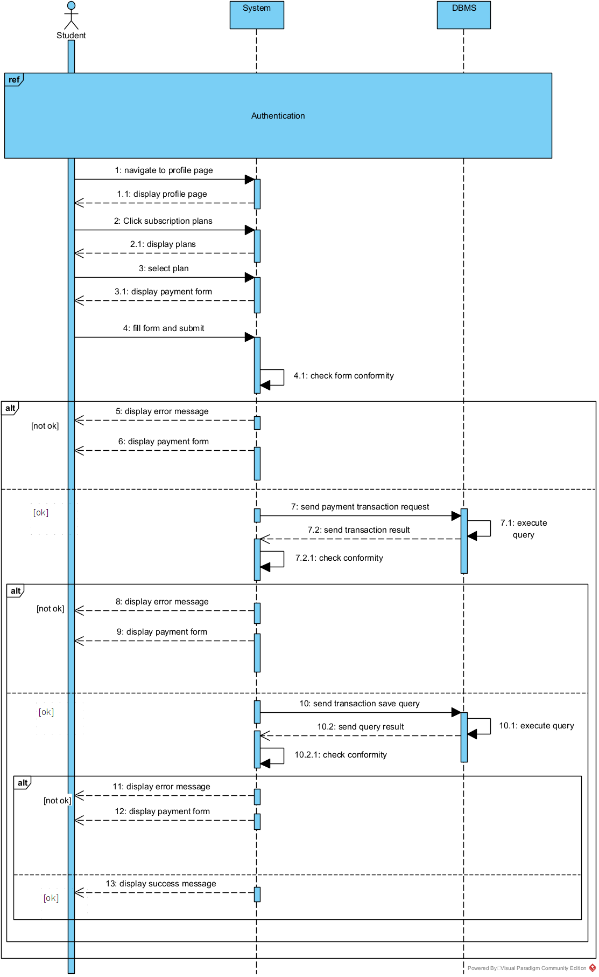
Figure 17: Make Payement Sequence Diagram

4) Activity diagram

a. Definition
An activity diagram is a graphical representation of workflows that show the steps needed in the realization of a process, showing the details from a start point to an end point through all decisions and actions that can possibly be performed. Activity diagrams are intended to model both the computational and organizational processes. The flow can be sequential, branched, or concurrent. Below is an activity diagram formalism.

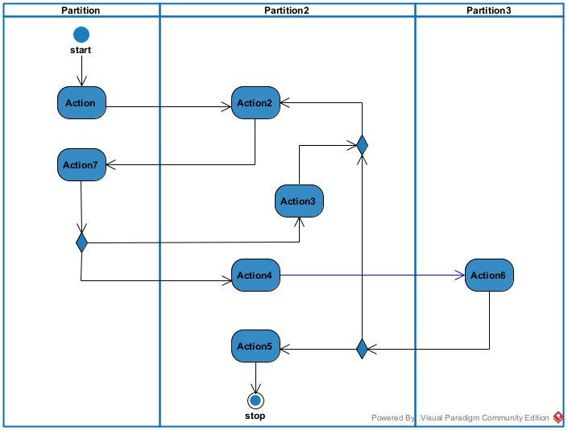
b. Formalism
Figure 18: formalism of activity diagram

c. Elements of Activity Diagram
Table 14: elements of an Activity diagram
Elements Diagrammatic Representation |  | Description
Activity | 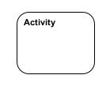 | Used to represent a set of actions.
Action | 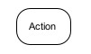 | Represent a task to be performed.
Activity edge |  | A directed connection between two activity nodes through which tokens may flow.
Initial node |  | Shows the beginning of an activity or set of actions.
Final node |  | Stops all controls and object flows in an activity.
Object node | 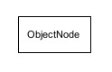 | Represents an object connected to a series of object flows.
Decision node | 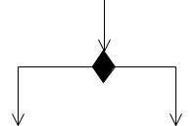 | Represents a test condition that splits an incoming activity edge into opposite outgoing activity edges.
Merge node | 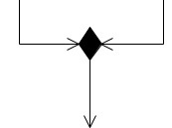 | Reunite different decision paths created using a decision node.
Fork node | 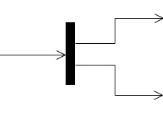 | Splits behavior into parallel or concurrent flows of activities  (or actions)
Join node | 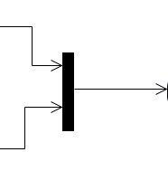 | Unites a set of parallel or concurrent flows of activities or actions.
Swim lane and partition | 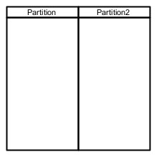 | A way of grouping activities performed by the same actor in an activity diagram, or to group actions in the same thread.

d. Authentication Activity diagram:
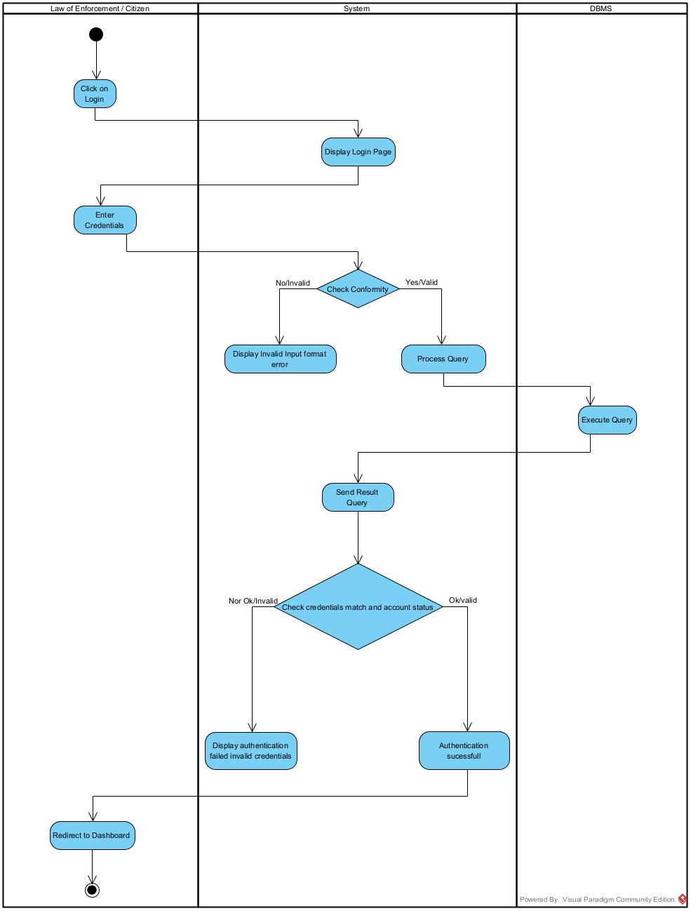
Figure 19: Authentication Activity diagram

e. Level Selection Activity Diagram
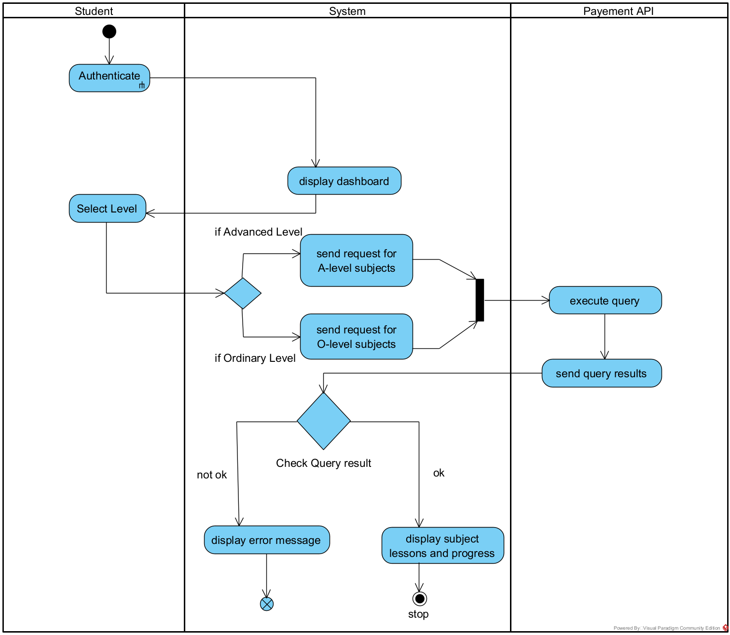
Figure 20: Level Selection Activity Diagram

f. Payment Activity Diagram (Subscription)
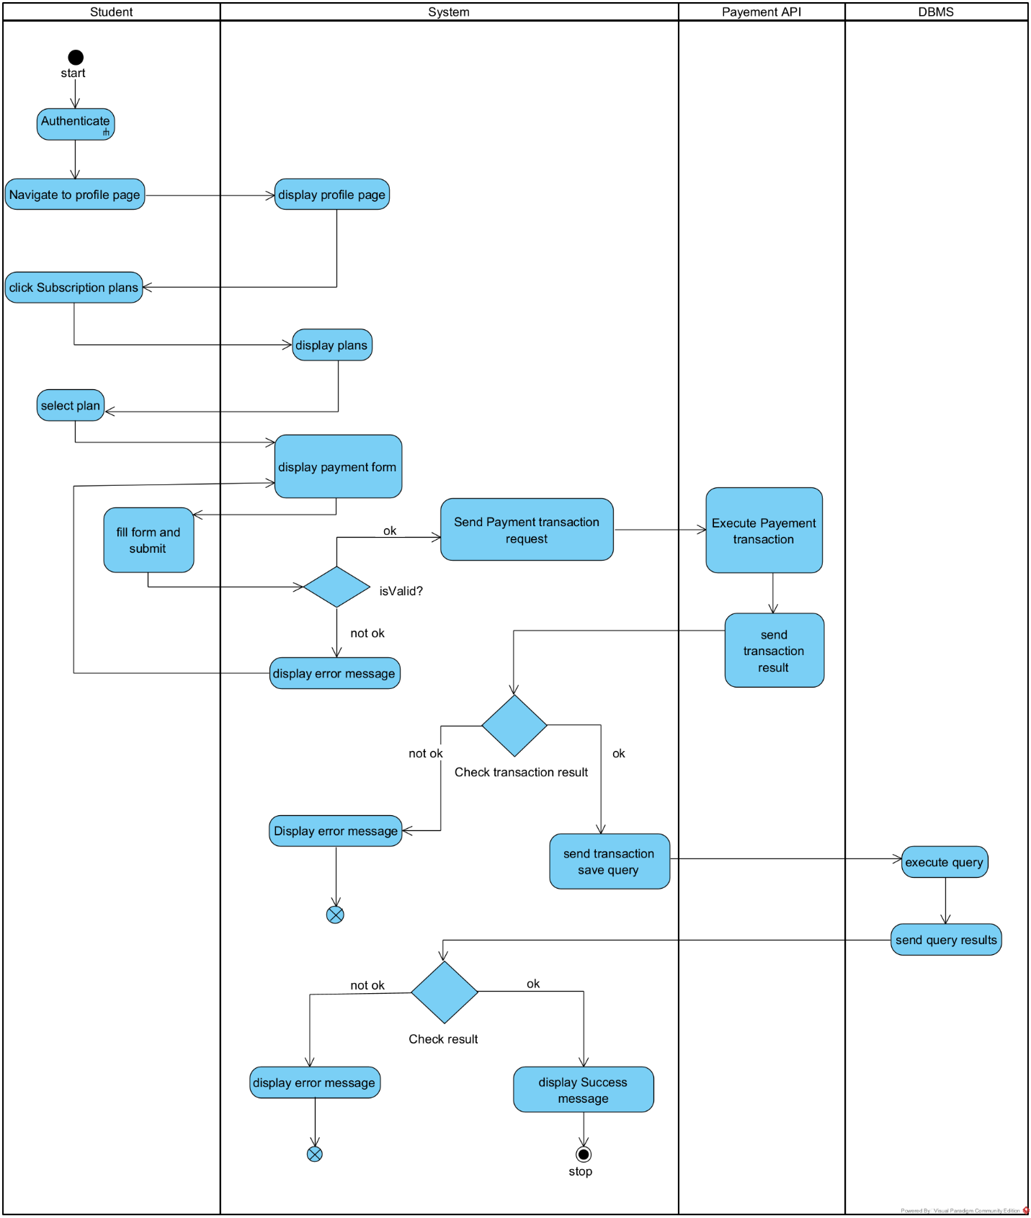
Figure 21: Payment Activity Diagram

CONCLUSION
In the analysis phase, we chose a software development process and modelling language, after which we explained the functional needs of our system. We saw the use case diagram, which shows the relationship between the actors and use case (the action the actor can perform on the system),we saw the communication diagram, which represents the architecture of the system based on object-oriented programming; we saw the sequence diagram, which represents the flow of messages between elements in the system; and lastly, the activity diagram, which shows the workflow of our system. We will now move to the conception phase in which we will present the technical branch of our system together with related diagrams.

PART IV: CONCEPTION PHASE

Preamble
The conception phase will permit us to present in an orderly manner the components necessary for the good functioning of our software and also the architecture used for the proposed solution. It bridges the gap between the analysis phase and the realization phase.

Content
INTRODUCTION
- TECHNICAL BRANCH
- CAPTURE OF TECHNICAL NEEDS
- RELATED UML DIAGRAM
- Class Diagram
- State machine Diagram
- Package Diagram
CONCLUSION

INTRODUCTION
The conceptual phase will describe in details the necessary specifications, features and operations that will satisfy the functioning requirements of the proposed system as modelled in the analysis phase. This phase is meant to identify and consider essential components (hardware /or software), structure (network capabilities), processes and procedures for the system to accomplish it objectives. We will look at some diagrams such as the component diagram, package diagram, communication diagram, class diagram and the object diagram.

I. TECHNICAL BRANCH

CAPTURE OF TECHNICAL NEEDS

1) Physical architecture
The design of the DBMS depends on its architecture. An n-tier architecture partitions on the whole system into related but separated n modules, which can be independently modified, altered, changed or replace. A large amount of data on web servers, personal computers (pc) and others is link with networks with the help of basic client or server architecture. Within the scope of our project, we made use of the n-tier architecture This architecture separates it tiers from each other based upon the user and the manipulated data in the database. Each layer has a well-defined communication interface, and the evolution of the layer is independent of the other. The n-tier of our system is made up of:
- The client tier, which is also known as our presentation interphase.
- Application Tier, which represents our webserver.
- The data tier, which represents our DBMS server.
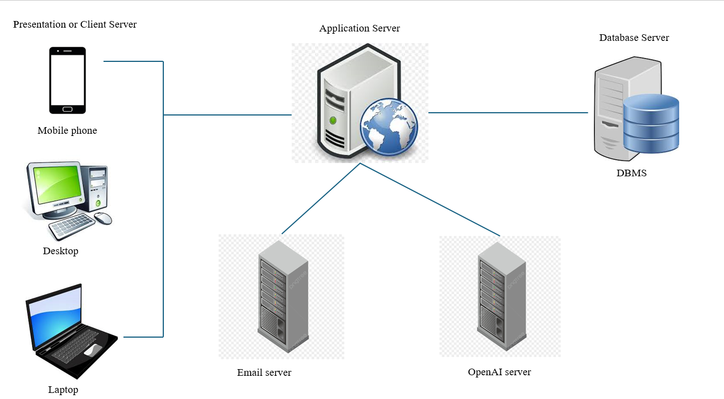
Figure 22: Physical n-tier Architecture

2) Logical architecture
Model View Controller, or MVC as it is popularly called, is a software design pattern for developing applications. A model-view-controller pattern is made up of the following three parts.
- Model: The lowest level of the pattern, which is responsible for maintaining data.
- View: This is responsible for displaying all or a portion of data to the user.
- Controller: It handles software code that controls the interactions between the model and the view.
MVC is popular as it isolates the application logic from the user interface and supports the separation of concerns. Here, the controller receives all requests for the application, then works with the model to prepare data needed by the view. The view then uses the data prepared by the controller to produce a final response. The MVC can be represented as follows:
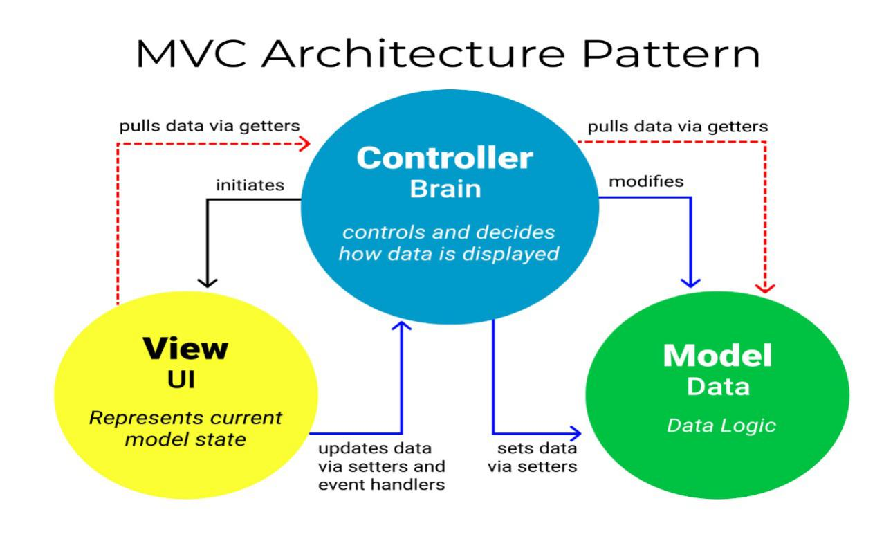
Figure 23:Logical MVC Architecture

II. RELATED UML DIAGRAMS

1. Class Diagram

a. Definition
A class diagram is a static diagram. It represents the static view of an application. class diagram is not only used for visualizing, describing, and documenting different aspects of the system but also for constructing executable code of the software application. A class diagram describes the attributes and operations of a class and constraints imposed on the system. Its purpose is to model the static view of an application.

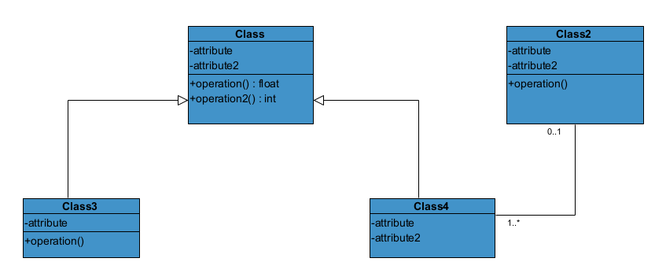
b. Formalism:
Figure 24 : formalism of class diagram

c. Class Diagram Elements Description
Table 15: Elements of a class diagram
Element | Representation | Description
class | 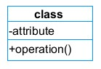 | A class is an element that defines the attributes and behaviors that an object can generate.
Composition | 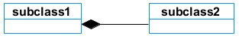 | If a parent of a composite is deleted, usually, all of its parts are deleted with it.
Aggregation | 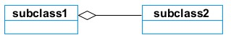 | If the parent of the aggregate is deleted, usually the children are not deleted.
Dependency | 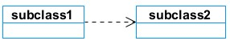 | It exists between two classes; if one changes, it may cause a change in the order, but not the other way around.
Generalization | 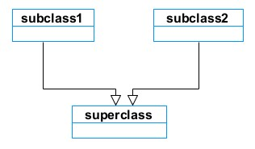 | It is a relationship between a whole thing (called a superclass) and a more specific thing (called a subclass)
Association | 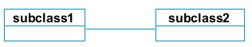 | It is a general type of relationship between elements, which may include cardinality, roles, etc.

d. System class diagram
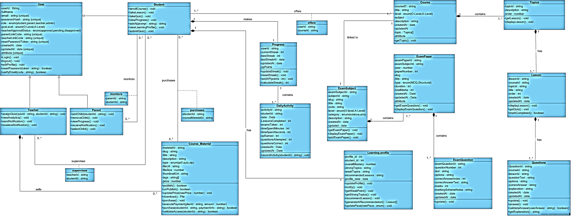
Figure 25: System Class Diagram

2. State Machine Diagram

a. Definition
A state machine diagram describes the behavior of a single object in response to a series of events in a system. Also known as a state machine diagram, it models the dynamic flow of control from the state of a particular object within a system.

b. Formalism:
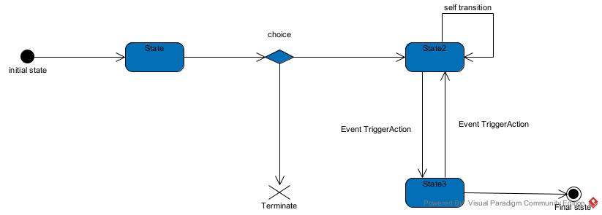
Figure 26: Formalism of the state machine diagram

c. State Machine Diagram Elements
Table 16: elements of a state machine
Components | Diagram Relationship | Description
State | 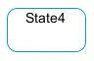 | Models a situation in which a certain invariant condition holds.
First (Initial) State |  | It represents a default vertex, that is, a source for a single transaction to the default or composite state.
Final State |  | A state specifying that the enclosing region is complete.
Transition | 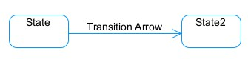 | A direction relation between a source and a target vertex.
Choice pseudo State |  | A diamond symbol that indicates a dynamic condition with branched potential results
Terminate |  | Implies that the execution of a state by means of its context is terminated.
Diagram Overview | 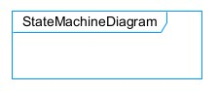 | A placeholder for the linked states in a state machine diagram.

d. User State Machine Diagram
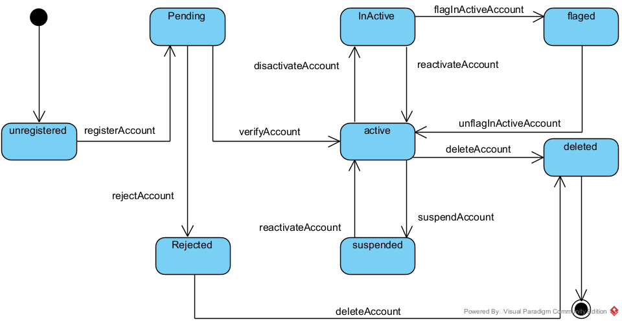
Figure 27: User State Machine Diagram

e. Student Course (Subject) State Machine Diagram

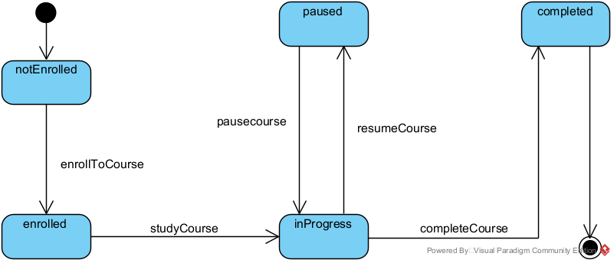

Figure 28: Student Course (Subject) State Machine Diagram

3. Package Diagram:

a. Definition:
This is a structural diagram used to show the organization and arrangement of various model elements in the form of packages. A package diagram is the grouping of related UML elements, such as classes, diagrams, or even other packages.

b. Formalism:
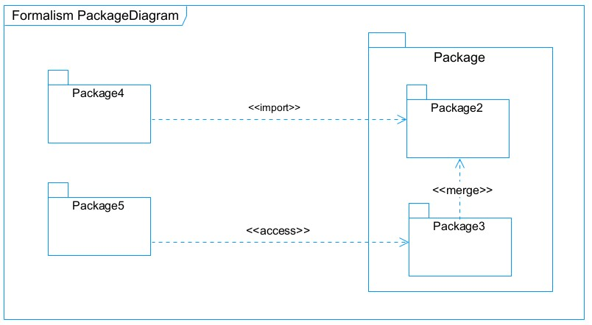
Figure 29: formalism of package diagram

c. Formalism for package diagram
Table 17: elements of a package diagram
Name | Representation | Description
Package | 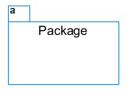 | A package is a namespace used to group related elements; it is a mechanism used to group elements into a better structure in a system.
Package import | 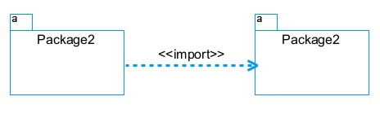 | A relationship indicates that functionality has been imported from one package to another.
Package access | 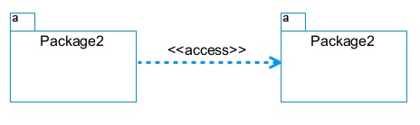 | A relationship indicates that one package requires assistance from the function of another package.
Package merge | 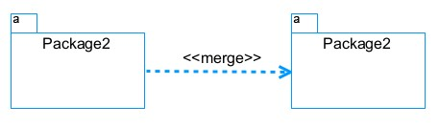 | It is a relationship that shows that the functionality of two packages is combined into a single function.

d. System package diagram
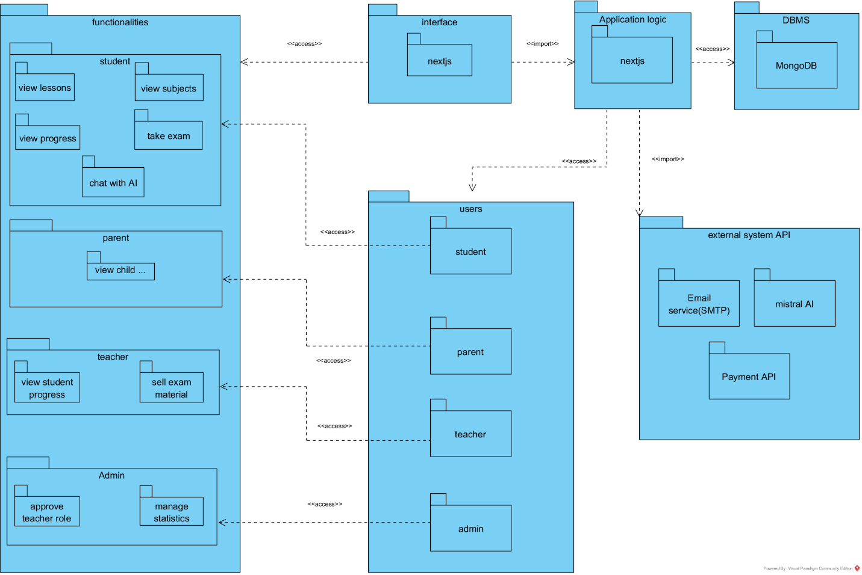
Figure 30: System Package Diagram

CONCLUSION
In the conception phase, we set as an objective to plan the different aspects of our system by showing how it will be structured and deployed within existing technical architectures. We began by taking into account the technical constraints for our system, after which we proceeded to identify the components of our system, how they are grouped, and how they should be deployed on appropriate deployment targets. We finished this phase by looking at interactions between the various aspects and actors of our system. The next phase of our report is the realization phase, where we will look at aspects concerning the implementation of our system.

PART V: REALISATION PHASE

Preamble
In this phase we will straight forward in the implementation of our solution. We will base ourselves on the analysis and the conception phase

Content

INTRODUCTION
- PRELIMINARY CONCEPTION
- Component Diagram
- Deployment Diagram
- TECHNOLOGICAL CHOICES
- Material Choices
- Software Choices
- Technological Choices
CONCLUSION

INTRODUCTION
Here in the realization phase, we will concentrate on building or implementing our solution, based on the different analyses and conceptions that we had carried out, which will help to facilitate our work. This phase is as critical as the previous phases. We are going to look at the relationship that exists between the entities of the entity relational diagram. Furthermore, we will see the choices of technologies used for the implementation of our system.

I. PRELIMINARY CONCEPTION:

1. Component Diagram:

a. Definition:
Component diagrams are used to model the physical aspect of a system. Now the question is what is this physical aspect? They are elements such as Executables, libraries, files, documents etc., which resides in a node. The component diagram does not describe the functionality of the system, but it describes the components used to make those functionalities.

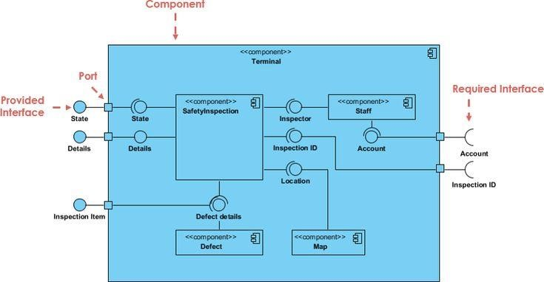
b. Formalism:

Formalism for component diagram
Table 18: elements of a component diagram
NAME | REPRESENTATION | DESCRIPTION
A component | 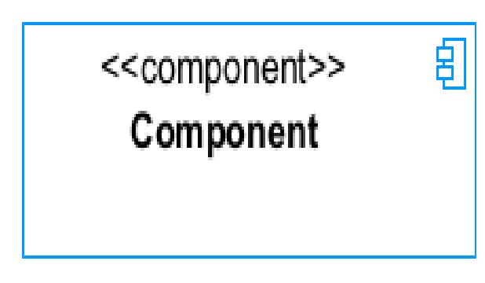 | A component is an abstract logical unit block of a system. It is represented as a rectangle with a smaller rectangle in the upper right corner, which serves as its icon for recognition.
Dependency | 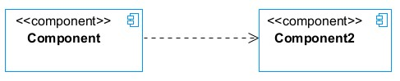 | Dependency is a directed relationship that is used to show that some components are dependent on others for their correct functioning.
interface | 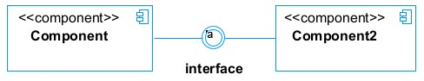 | An interface is a circle or a semicircle attached to a stick that looks like a lollipop. It describes groups of operations provided or required by components.
port | 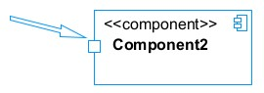 | A port (represented by a small square at the end of a required or provided interface) is used when the components delegate the interfaces to an internal class.

System component diagram
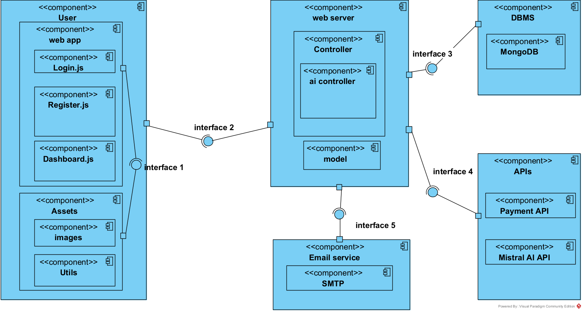
Figure 31: system component diagram

2. Deployment diagram:

Definition:
Consists of nodes. Nodes are nothing but physical hardware used to deploy the application. A deployment diagram is a structural diagram used to visualize the topology of the physical components of a system, where the software is deployed. They consist of nodes and their relationship. It is related to the component diagram because the components are deployed using the deployment diagram. A deployment diagram

Formalism:

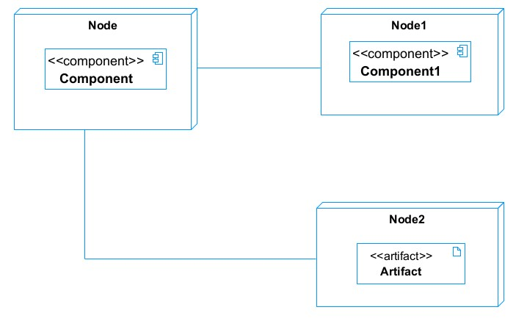

Elements of Deployment Diagram
Table 19: elements of deployment diagram
Element | Representation | Description
Node |  | It is hardware used to deploy the application.
Artifact | 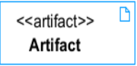 | An artifact is a major product that is produced or used during the development of software. E.g., diagrams, data models, setup scripts
Component |  | It represents a modular part of a system that encapsulates its content and whose manifestation is replaceable within its environment.
Association |  | An association helps to connect two nodes, which permits them to communicate together.

System deployment diagram
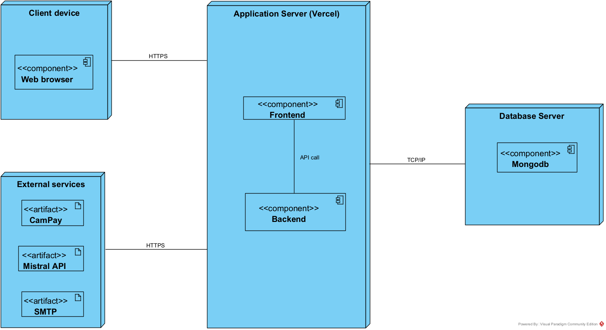
Figure 32: System Deployment Diagram

TECHNICAL CHOICES
Table 20: technical choice
Material | Quantity | Function | Image
FUJITSU | 1 | The computer was used for the programming of the microcontroller, the analysis, research, and the design of the system architecture. This was the main component of this project. | 
TECHNO | 1 | For testing app responsiveness | 

Software | Role | Reason for use | Image
OS  WINDOWS  10 | The operating system required to run the software is the one on which we have worked. | Windows 10 has a user-friendly interface that is familiar to many users, making it easy to navigate and use. | 
Visual Paradigm | The software engineering workshop is used for solution modelling. We utilized this tool for modelling the various diagrams of our system | . Supports multiple modelling languages and methodologies, making it suitable for various project requirements and enabling teams to adapt to different development processes. | 
Visual stAudio code | Visual Studio Code is a lightweight, open-source code editor developed by Microsoft, supporting multiple programming languages. Used for writing application code. | . Combines tools for version control, debugging, and terminal access in one interface, improving efficiency and reducing the need for multiple applications. | 
Github | It is a website and cloud service that helps developers store and manage their code. | Git allows developers to track changes, revert to previous versions, and maintain a history of modifications, ensuring that no work is lost and enabling easy recovery. | 
Nextjs | A powerful React framework for building fast full-stack web applications that efficiently handles server-side rendering, static site generation, and backend API routes out of the box. | It simplifies full-stack development by combining fast React frontends and powerful backend server routes inside a single, high-performance framework. | 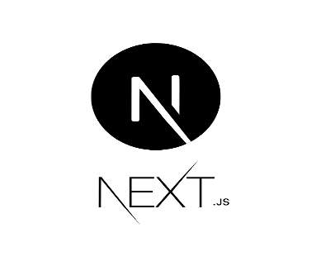
Mongodb | MongoDB is a NoSQL, document-based database that stores data as flexible, JSON-like records (called documents) instead of rigid tables with rows and columns. | MongoDB writes and reads JSON-like data at lightning-fast speeds | 
Postman | Postman is a collection platform for API development that allows users to design, test, and document APIs | Postman simplifies the process of testing APIs with an intuitive interface, allowing developers to construct requests, inspect responses and debug issues easily | 
MS Word | MS Word is a widely used word processing application that allows users to create, edit, and format text documents. Use in the creation of the report | Offers extensive options for formatting text, images, and layouts, enabling the creation of professional-quality documents. | 
MS PowerPoint | MS PowerPoint is a presentation software that allows users to create dynamic slideshows comprising text, images, videos, and animations. Able to create slideshow presentations for the application. | Its intuitive interface and templates make it easy for users to create professional presentations quickly, regardless of their technical skill level | 
Chrome | Google Chrome is a fast, secure, and user-friendly web browser developed by Google. Used to test our application UI | Chrome is optimized for fast page loading and efficient resource management, providing a smooth browsing experience. | 
GanttProject | GanttProject is a free, open-source project management tool that allows users to create Gantt charts for planning and scheduling projects | Allows users to assign tasks, set deadlines, and manage resources effectively, facilitating better project coordination and efficiency. | 
Mistral | Mistral is a fast, efficient open-source AI language model. | Mistral AI functions as a highly adaptable reasoning and text-generation engine | 

CONCLUSION
In our realization phase, we set as an objective to plan the different aspects of our system by showing how it will be structured and deployed within existing technical architectures. We began by taking into account the technical constraints for our system, after which we proceeded to identify the components of our system, how they are grouped, and how they should be deployed on appropriate deployment targets. We finished this phase by looking at interactions between the various aspects and actors of our system. The next phase of our report is the realization phase, where we will look at aspects concerning the implementation of our system.

PART VI: FUNCTIONALITY TESTING

Preamble
In this phase, we will present the various functionalities of our application.

Content

INTRODUCTION
- APPLICATION FUNCTIONALITIES
- TEST SHOWCASE
CONCLUSION

INTRODUCTION
The test of functionalities phase helps us to know more about the solution we are building, be it web or mobile. It provides the different functionalities or modules found in our application and how they are beneficial to the users. Hence, we are going to explore the different functionalities present in our school fees tracking and payment reminder system.

I.APPLICATION OF FUNCTIONALITIES
- Authentication: This functionality enables users to have access to their workspace or dashboard. In case he/she does not have an account, he/she will register.
- Take lessons: This functionality enables students to learn on the platform using the available course materials created. It is mainly from here that students can progress in learning
- Take exams: This functionality permits students to test their actual level of understanding of a particular subject after taking some lessons and answering quizzes
- Monitor progress: This functionality is distributed across parents, students, and teachers. Students can view their own progress, and teachers, together with parents, can do so as well, just as long as they are connected to that student.
- Correct mistakes: this functionality allows students to be able to correct mistakes they made when answering previous questions, whether in exams or in lesson quizzes
- Get AI recommendations: A feature that uses AI to analyze student activity on the platform and recommend next steps or corrections.

II.TEST SHOWCASES
a. Login API testing at the api/auth/login endpoint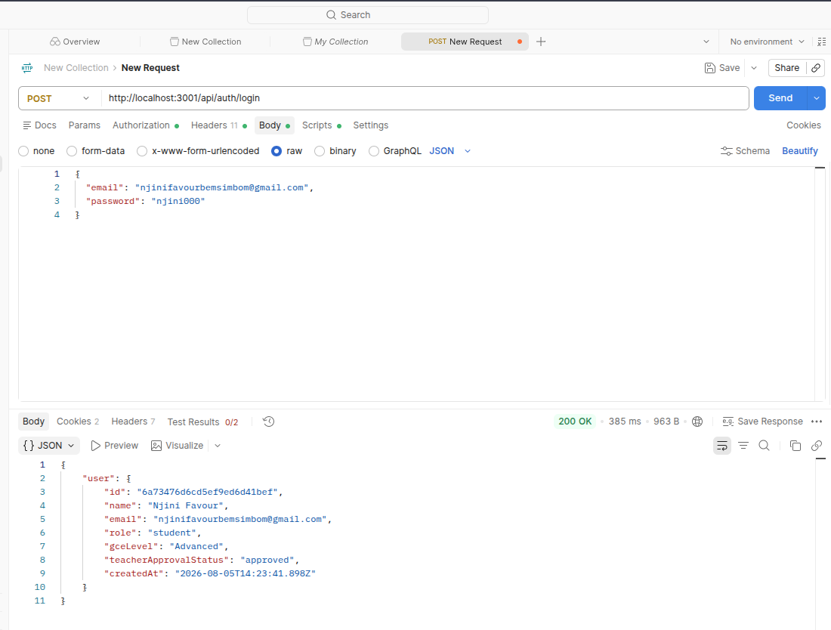
Figure 33: Login Testing

b. Fetching advanced-level courses (subjects)
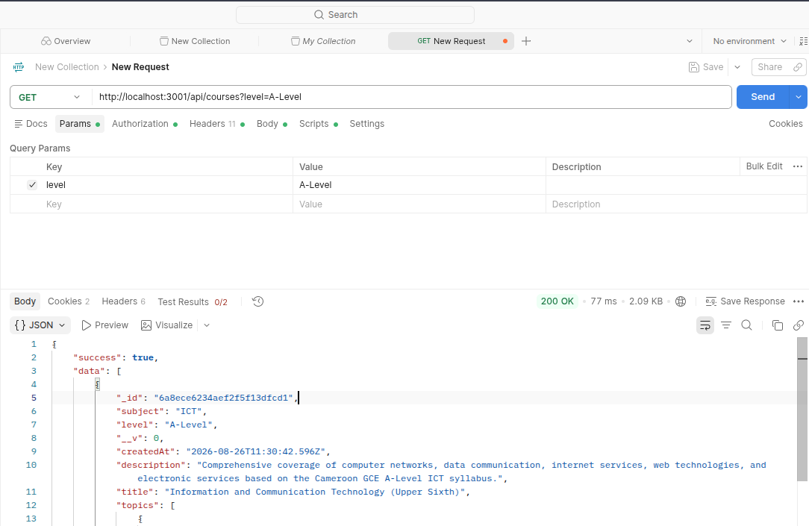
Figure 34: Fetching Courses

c. Testing api/auth/me endpoint to fetch currently logged-in user
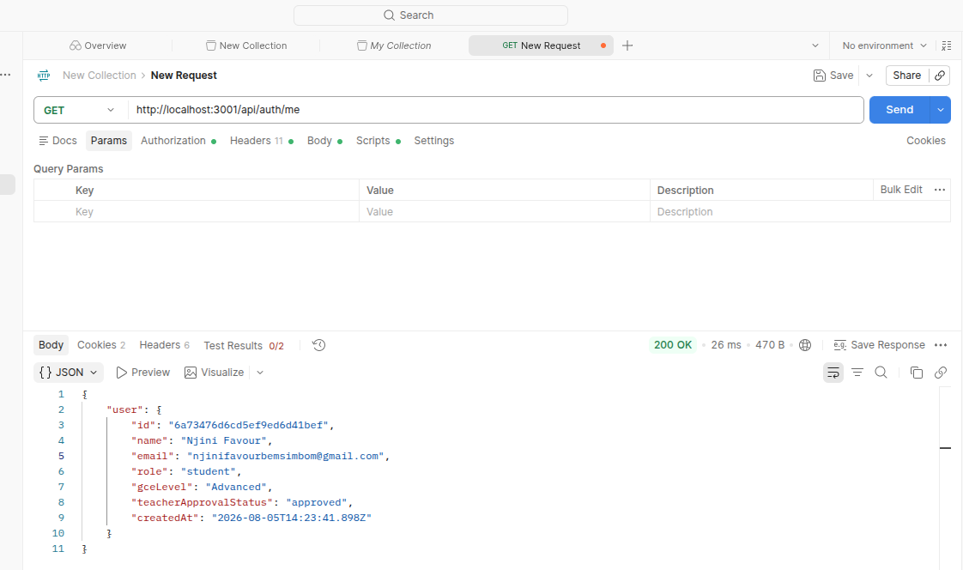
Figure 35: Fetching current authenticated user data

CONCLUSION
In the testing phase, we outlined the different functionalities of our platform and their benefits to users. This phase is crucial for understanding how the application operates and serves its users effectively. We will now transition to the final phase, which is the installation and user guide. In this section, we will provide detailed instructions on how to install and use Pi.

PART VII: INSTALLATION AND USER GUIDE

Preamble
The purpose of the user guide is to provide users of our platform with step-by-step instructions on how to install and use the system.

Content

INTRODUCTION
- INSTALLATION
- USER GUIDE
CONCLUSION

INTRODUCTION
This is the final phase of our report. In this phase, we will walk through the requirements for our system, the necessary installation process, and accessing our system and its features, all this in a step-by-step manner to facilitate the setting up of the platform for first-time users. The steps of different processes will be accompanied by images. Afterward, we will showcase our application by viewing the different screens.

I. INSTALLATION OF THE APPLICATION

II. USER GUIDE
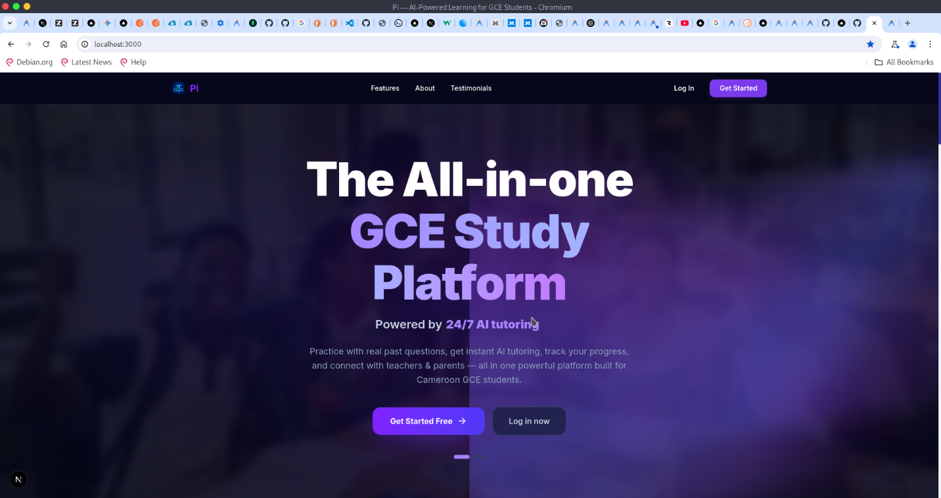
Figure 36: Landing Page
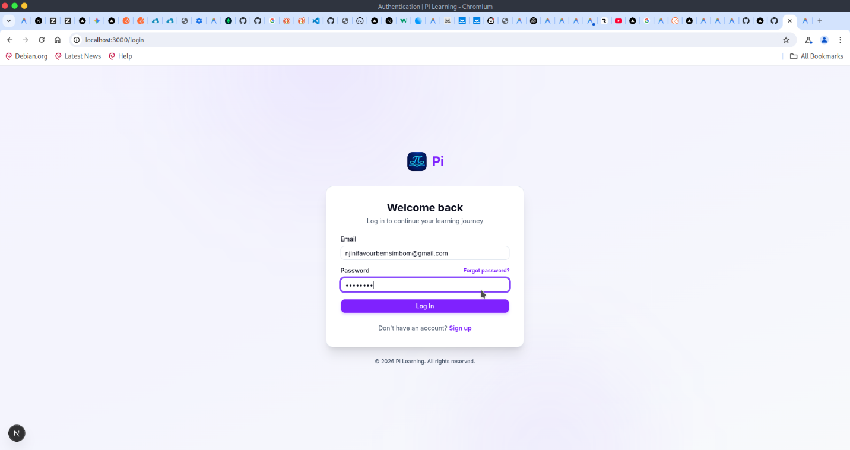
Figure 37: Login Page
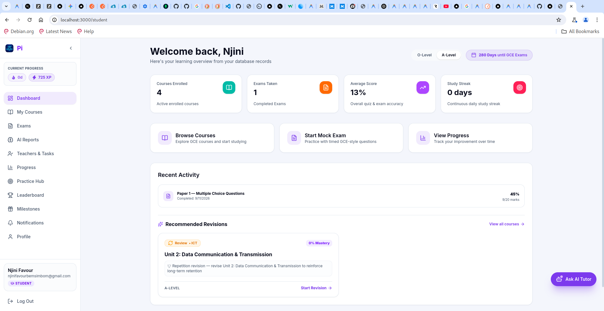
Figure 38: Student dashboard
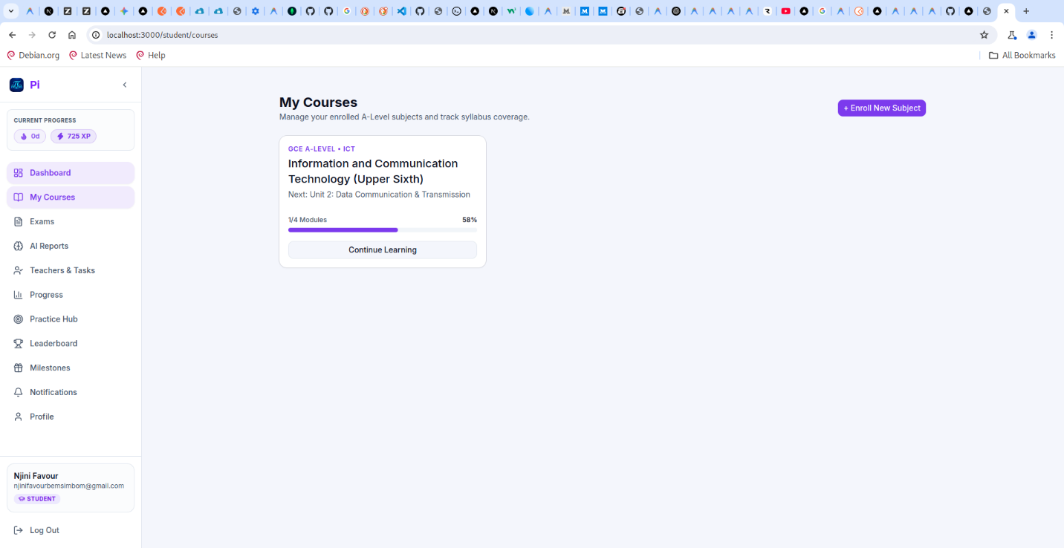
Figure 39: Student courses
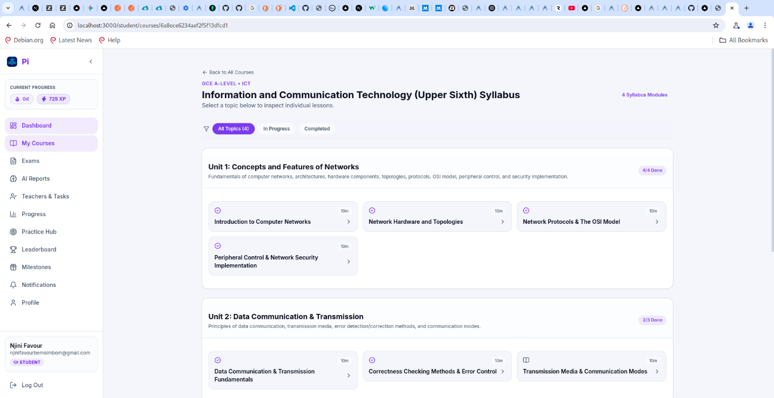
Figure 40: Topics page for course
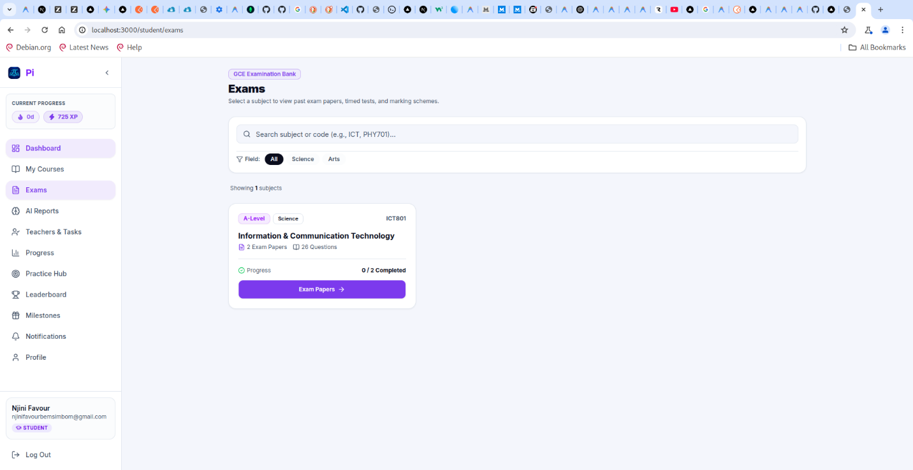
Figure 41:Examination page for taking various exams for different courses
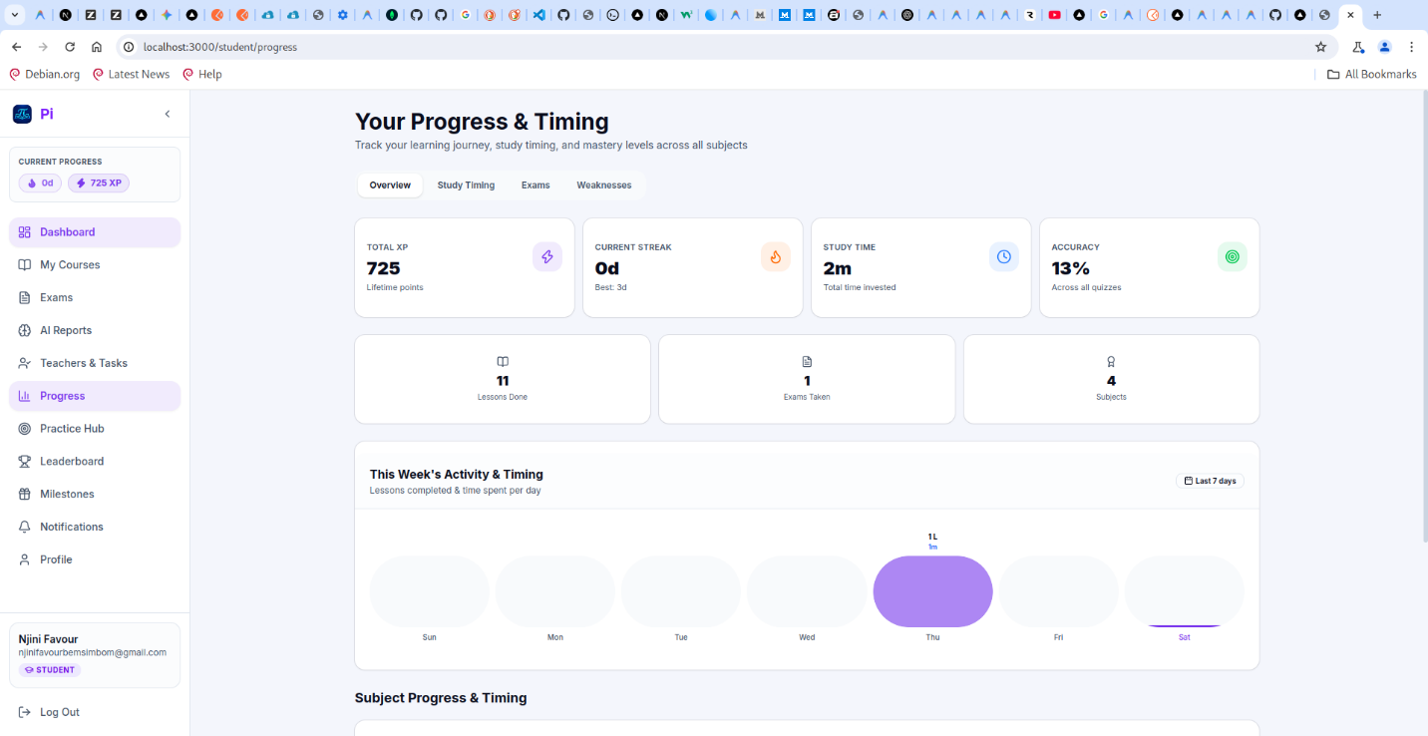
Figure 42: Student Progress page
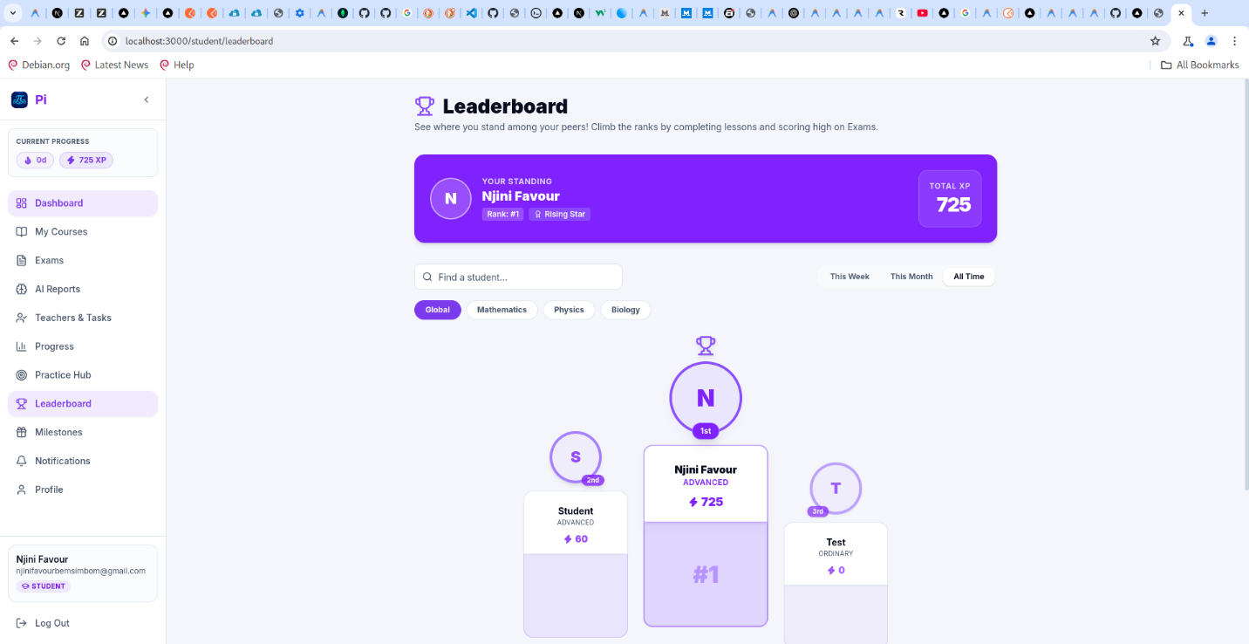
Figure 43: Student Leaderboard page
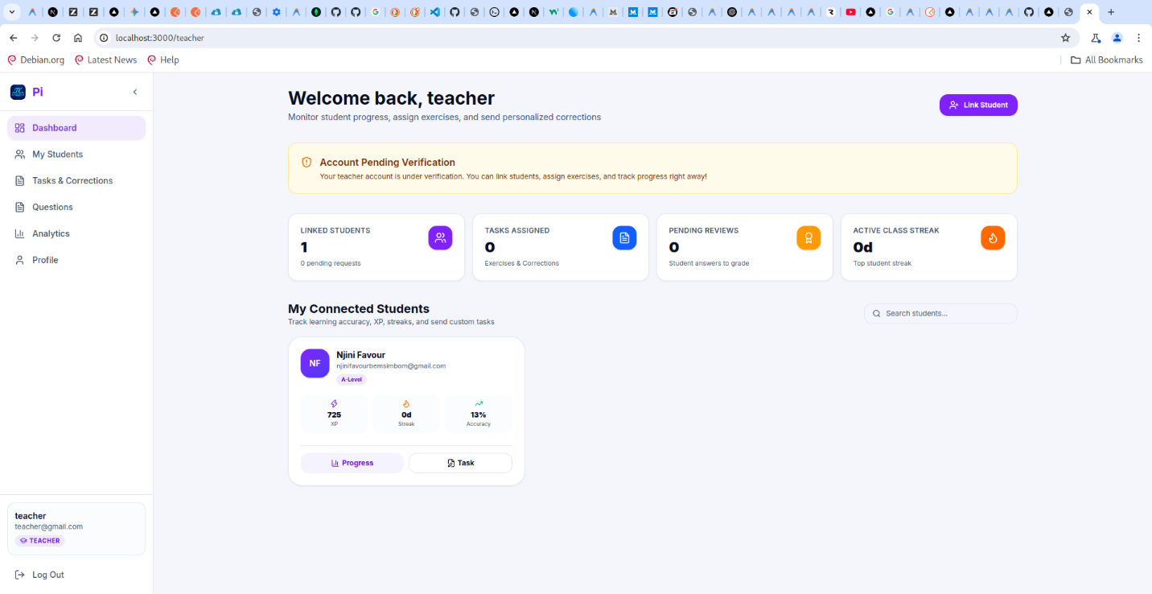
Figure 44: Teacher dashboard
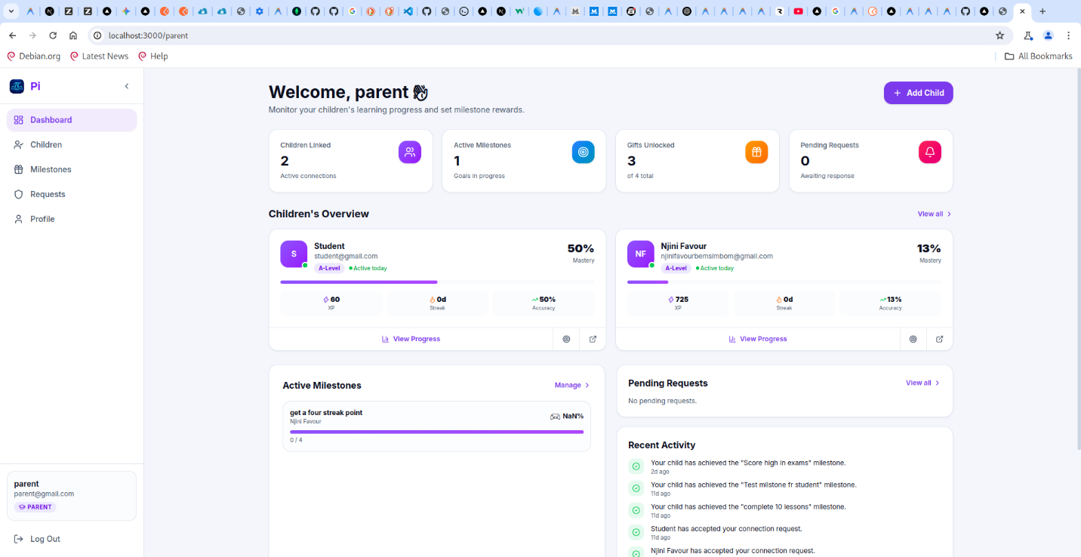
Figure 45: Parent dashboard

CONCLUSION
Pi is an innovative adaptive learning solution to students, helping them track their progress, and adapt respectively to their needs by recommending lessons and revision based on their past study activities and their results in order to improve themselves and help them study at their own pace effectively and efficiently. The installation and user guide has been seen above ande if followed carefully, navigation through the platform would be a piece of cake for the user.

GENERAL CONCLUSION
The three-month academic internship carried out at SHADERL provided a valuable opportunity to bridge theoretical knowledge acquired at the African Institute of Computer Sciences (AICS) with the practical demands of software engineering. This project was conceived to tackle critical challenges faced by secondary school students preparing for the Cameroon General Certificate of Education (GCE) Ordinary and Advanced Level examinations—specifically, inconsistent study habits, static learning content, limited personalized support, and a lack of real-time academic progress monitoring for teachers and parents.
To address these limitations, we designed and implemented an AI-Powered Adaptive E-Learning Platform tailored specifically to the Cameroon GCE curriculum. Following the Two-Track Unified Process (2TUP) methodology alongside UML modeling, we systematically separated functional requirements from technical architecture. The resulting platform transforms traditional exam revision into an interactive, gamified experience featuring daily study streaks, performance-based rewards, adaptive practice exercises, and automated AI tutoring. Furthermore, by delivering dedicated dashboards for Teachers and Parents, the platform fosters a collaborative educational ecosystem that enables timely academic guidance and continuous progress tracking.
Key Achievements
- Personalized & Adaptive Learning: Integrated an AI tutor capable of evaluating individual student performance, generating tailored explanations based on verified GCE marking schemes, and recommending revision paths.
- Enhanced Learner Engagement: Implemented gamification mechanics (XP, badges, daily streaks) to cultivate consistent study habits and combat last-minute exam preparation.
- Collaborative Academic Monitoring: Established dedicated teacher and parent interfaces for tracking performance analytics, assigning exercises, and sending progress alerts.
Perspectives & Future Work
While the core functional and technical objectives of this platform have been successfully realized, several perspectives remain open for future enhancement:
- Mobile & Offline Support: Developing a dedicated mobile application with offline access capabilities to cater to students in regions with limited internet connectivity.
- Expanded Subject & Question Banks: Broadening the automated question bank across more technical and arts disciplines.
- Complete Payment Integration: Fully deploying the optional Payment API module for seamless subscription management and premium feature unlockability.
In conclusion, this project demonstrates how artificial intelligence, gamification, and structured software modeling can modernize examination preparation in Cameroon, laying a foundation for scalable, tech-driven educational solutions across the region.

ANNEXES

BIBLIOGRAPHY
Group, O. M. (2017). OMG Unified Modeling Language (OMG UML).
Publications, M. (2026). Mercuriale.
shaderl. (n.d.). Shaderl documentation. Younde.

WEBOGRAPHY

TABLE OF CONTENTS
Table of Contents
DEDICATION i
ACKNOWLEDGEMENTS ii
RESUME iii
SUMMARY iv
CONTENT v
LIST OF FIGURES vi
LIST OF TABLES vii
LIST OF ABBREVIATIONS viii
GENERAL INTRODUCTION 1
PART ONE: INSERTION PHASE 2
INTRODUCTION 4
I- WELCOME AND INSERTION 5
II- GENERAL REPRESENTATION OF SHADERL 6
A-Background: 6
B- Mission 6
C-Vision 6
D- Activities 7
E- Products 7
III- ORGANISATION OF SHADERL 8
Executive Leadership 8
Software Engineering Department 8
Human Resource Department 8
Communication Department 9
Department of Financial Affairs 9
Functional organisation 10
IV- GEOGRAPHICAL LOCATION OF SHADERL 11
V- BRIEF PRESENTATION OF THE PROJECT THEME 12
CONCLUSION 13
PART TWO : TECHNICAL PHASE 14
PART I : THE EXISTING SYSTEM 16
INTRODUCTION 18
I. PRESENTATION OF THE THEME 19
II. DESCRIPTION OF THE EXISTING SYSTEM 20
a. Limited Adaptive Learning 20
b. User Experience Challenges 20
c. Limited Collaborative Learning Support 20
III. CRITICISMS OF THE EXISTING SYSTEM 21
IV. PROBLEMATIC 23
V. PROPOSED SOLUTION 24
CONCLUSION 25
PART II : SPECIFICATION BOOK 26
INTRODUCTION 28
I. CONTEXT AND JUSTIFICATION 29
1. Context 29
2. Justification 29
II. OBJECTIVES OF THE PROJECT 31
1. General Objective 31
2. Specific Objectives 31
III. EXPRESSION OF NEEDS 32
1. FUNCTIONAL NEEDS 32
2. NON-FUNCTIONAL NEEDS 33
IV. PROJECT PLANNING 35
1. Chronogram of activities: 35
2. Gantt chart 36
V. ESTIMATED COST OF PROJECT 37
1. SOFTWARE’S RESOURCES 37
2. HARDWARE RESOURCES 37
3. HUMAN RESOURCES 38
4. TOTAL PROJECT ESTIMATION 38
VI. CONSTRAINTS OF THE PROJECT 39
VII. LIST OF PARTICIPANTS AND DELIVERABLES 39
1. LIST OF PARTICIPANTS 39
2. DELIVERABLES 39
CONCLUSION 40
PART III : THE ANALYSES PHASE 41
INTRODUCTION 43
I. METHODOLOGY 44
1. Comparative study of UML and MERISE 44
2. Comparative study of the Unified Process 48
II. MODELLING OF THE SYSTEM 51
1) Use Case diagram 51
2) Communication Diagram 60
3) Sequence diagram 65
4) Activity diagram 70
CONCLUSION 76
PART IV: CONCEPTION PHASE 77
INTRODUCTION 79
I. TECHNICAL BRANCH 80
CAPTURE OF TECHNICAL NEEDS 80
II. RELATED UML DIAGRAMS 82
1. Class Diagram 82
2. State Machine Diagram 85
3. Package Diagram: 89
CONCLUSION 92
PART V: REALISATION PHASE 93
INTRODUCTION 95
I. PRELIMINARY CONCEPTION: 96
1. Component Diagram: 96
2. Deployment diagram: 99
• TECHNICAL CHOICES 102
CONCLUSION 107
PART VI: FUNCTIONALITY TESTING 108
INTRODUCTION 110
I.APPLICATION OF FUNCTIONALITIES 111
II.TEST SHOWCASES 112
CONCLUSION 115
PART VII: INSTALLATION AND USER GUIDE 116
INTRODUCTION 118
I. INSTALLATION OF THE APPLICATION 119
II. USER GUIDE 120
CONCLUSION 125
GENERAL CONCLUSION 126
ANNEXES viii
BIBLIOGRAPHY ix
WEBOGRAPHY x
TABLE OF CONTENTS xi

the official public high school exit and university entrance examination for students in the Anglophone education system of Cameroon
the official public high school exit and university entrance examination for students in the Anglophone education system of Cameroon
an educational method that uses computer algorithms and artificial intelligence to customize teaching, content, and pacing for each student in real time
educational mobile application designed to help secondary school students prepare for major national examinations through past papers, answer guides, and AI-powered study tools
Make something like a game (following some gaming logic like xp points)
Xp points are most popularly used in games and increases as a reward as players progress through it

